**Section 14 ) AWS Cloud Formation**

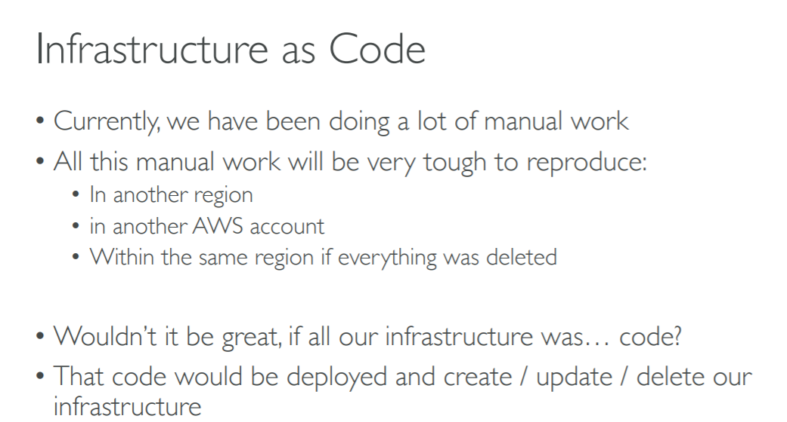

**Imp:**

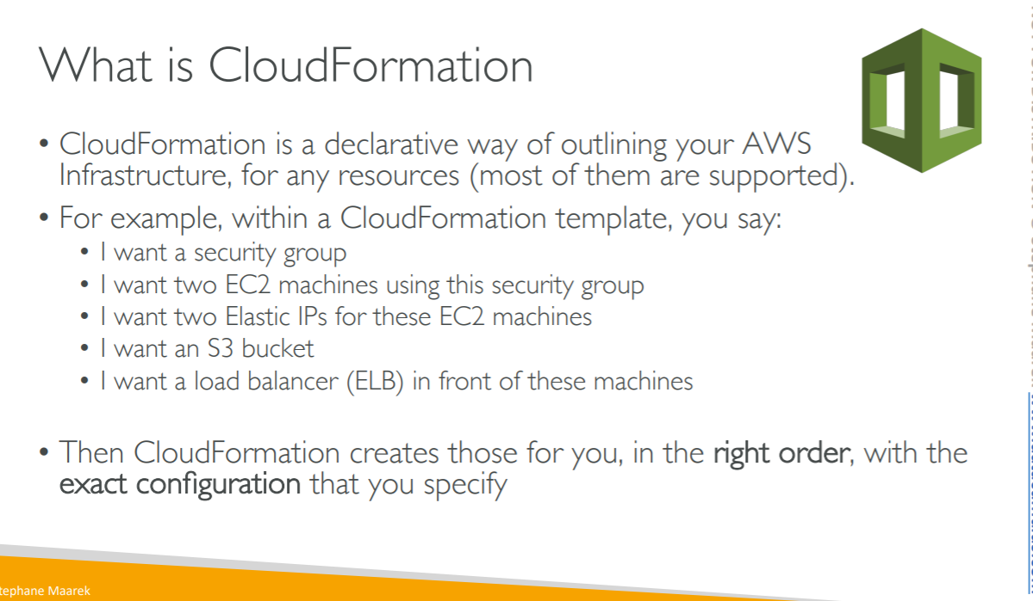

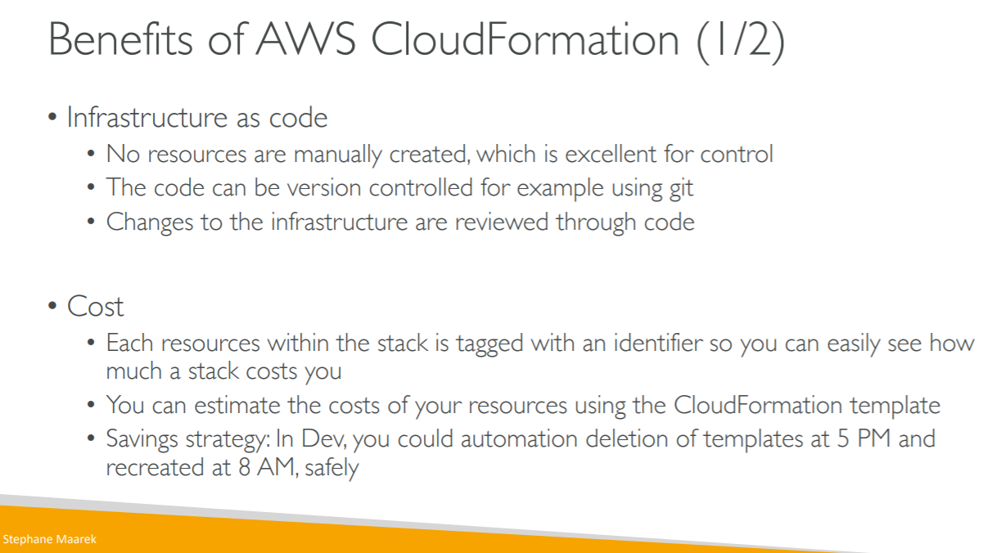

**NOTE : each time we create elastic beanstalk it will create cloud formation template behind the scene**

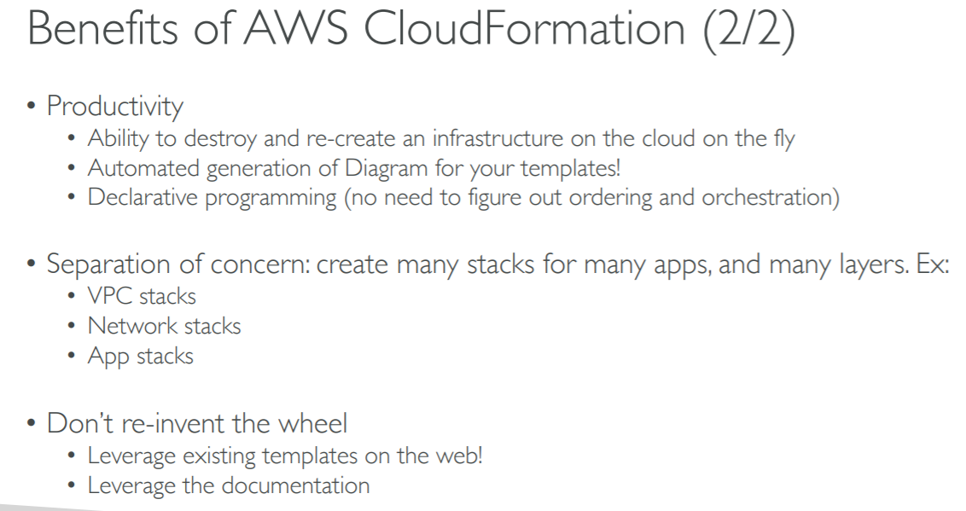

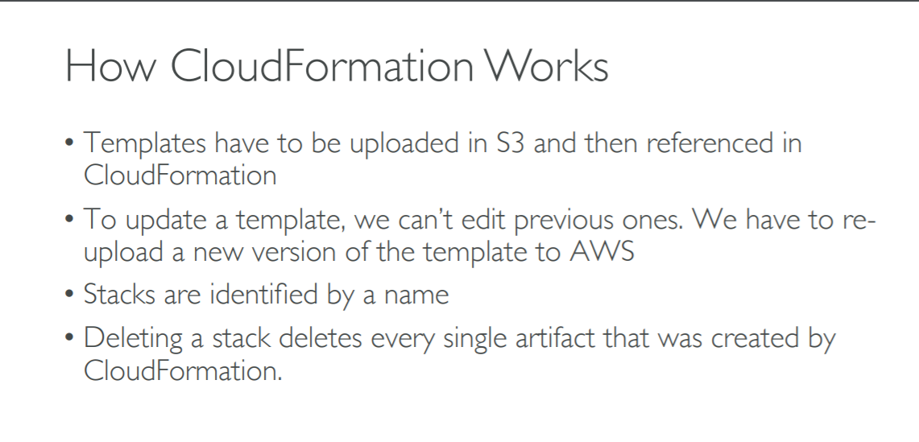

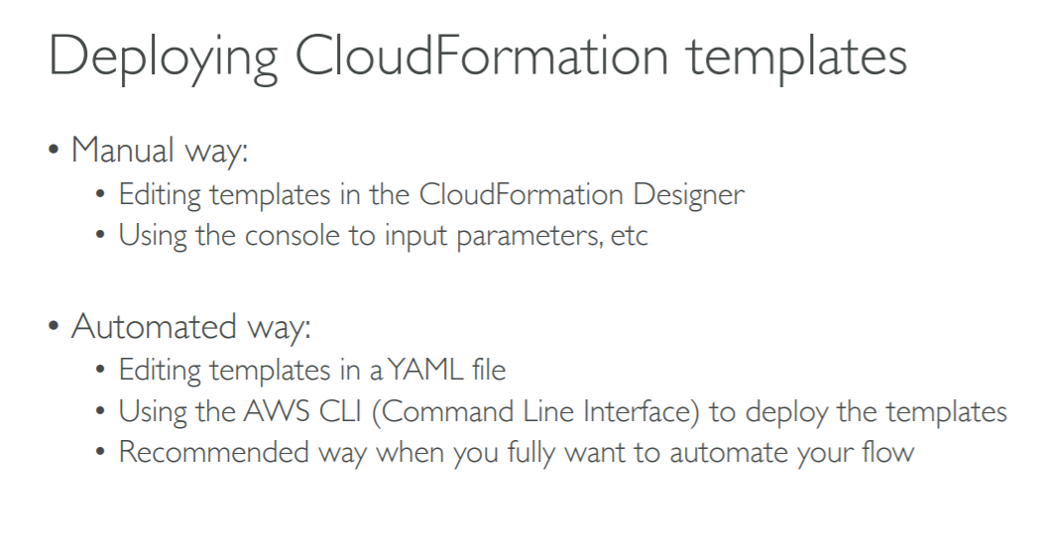

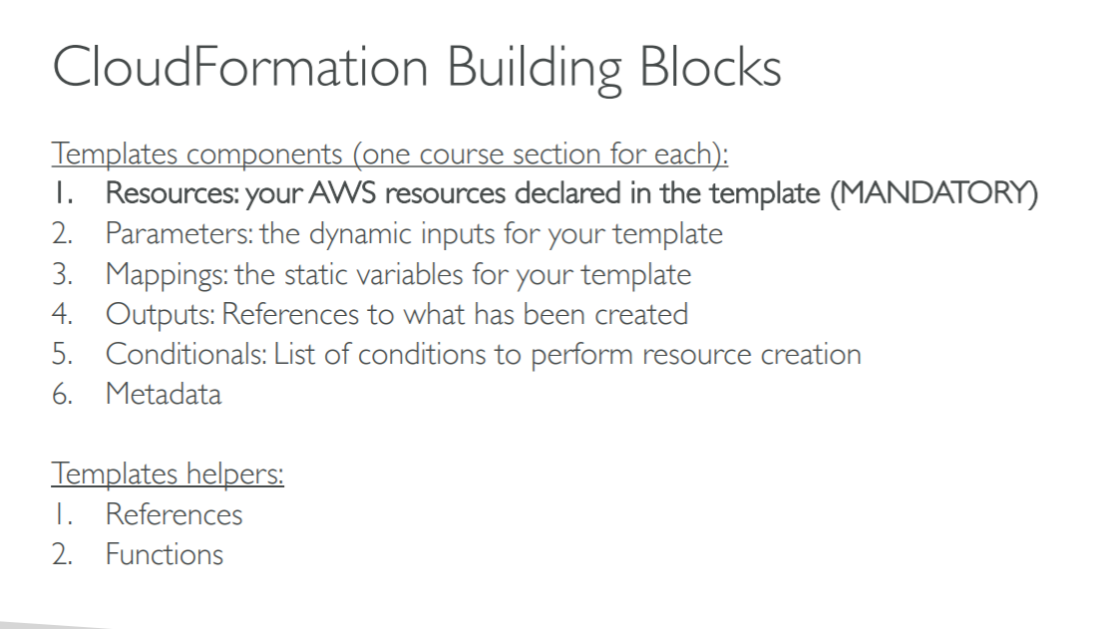

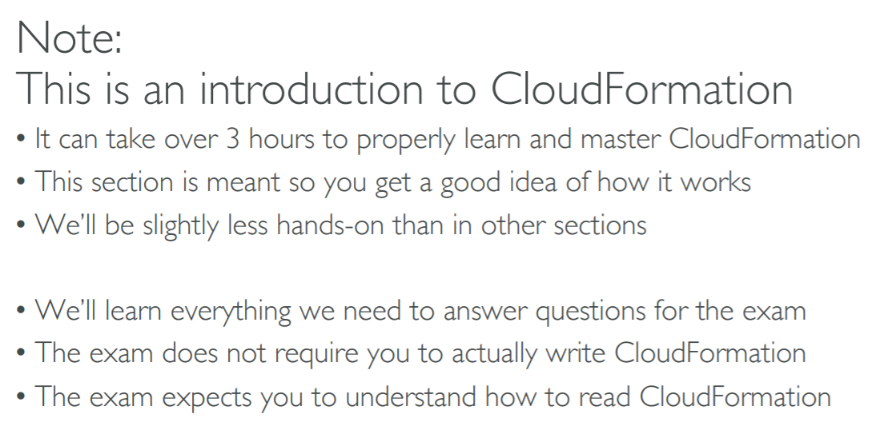

**Cloud formation create stack hands on**

**Create a cloud formation template will do below task**

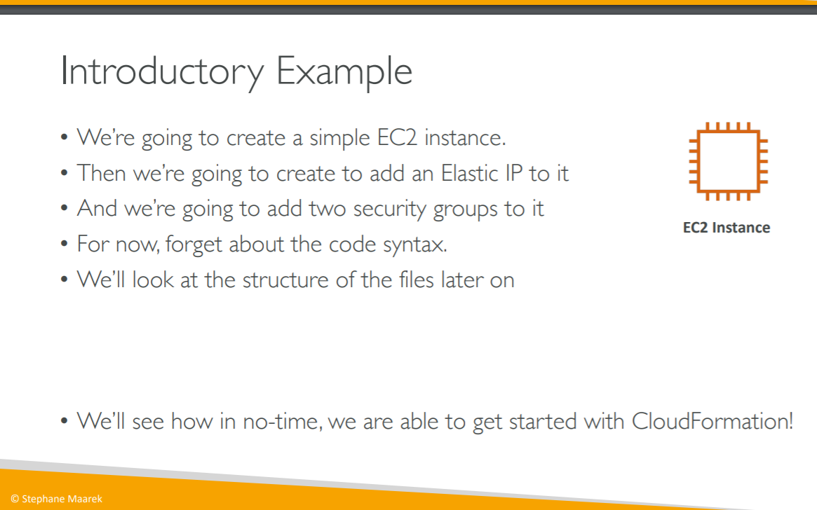

**Step1 ) go to cloud template**

**Click create stack**

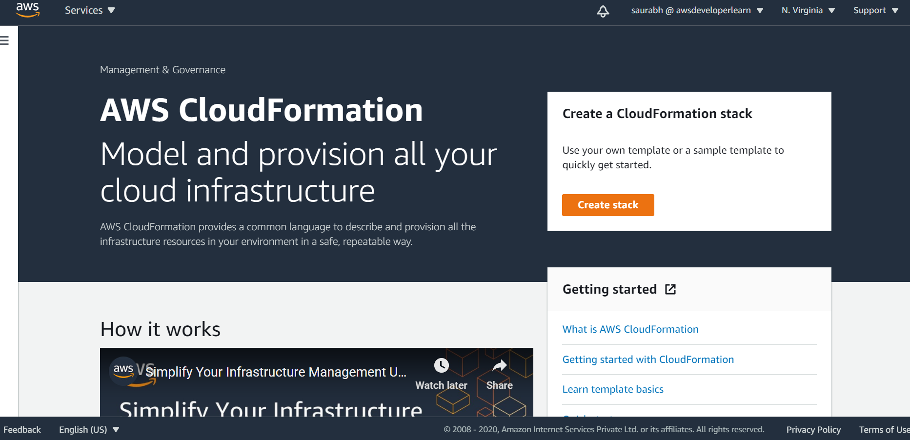

**Step 2) choose a file**

0-just-ec2.yaml

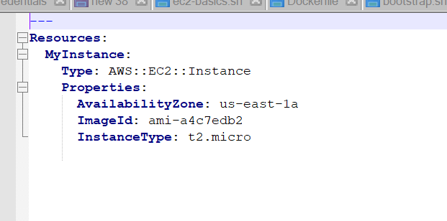

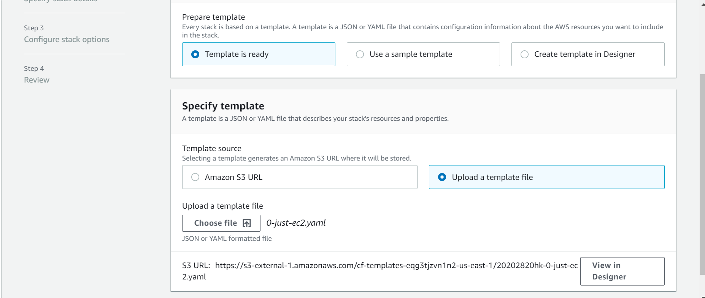

**Step 3)**

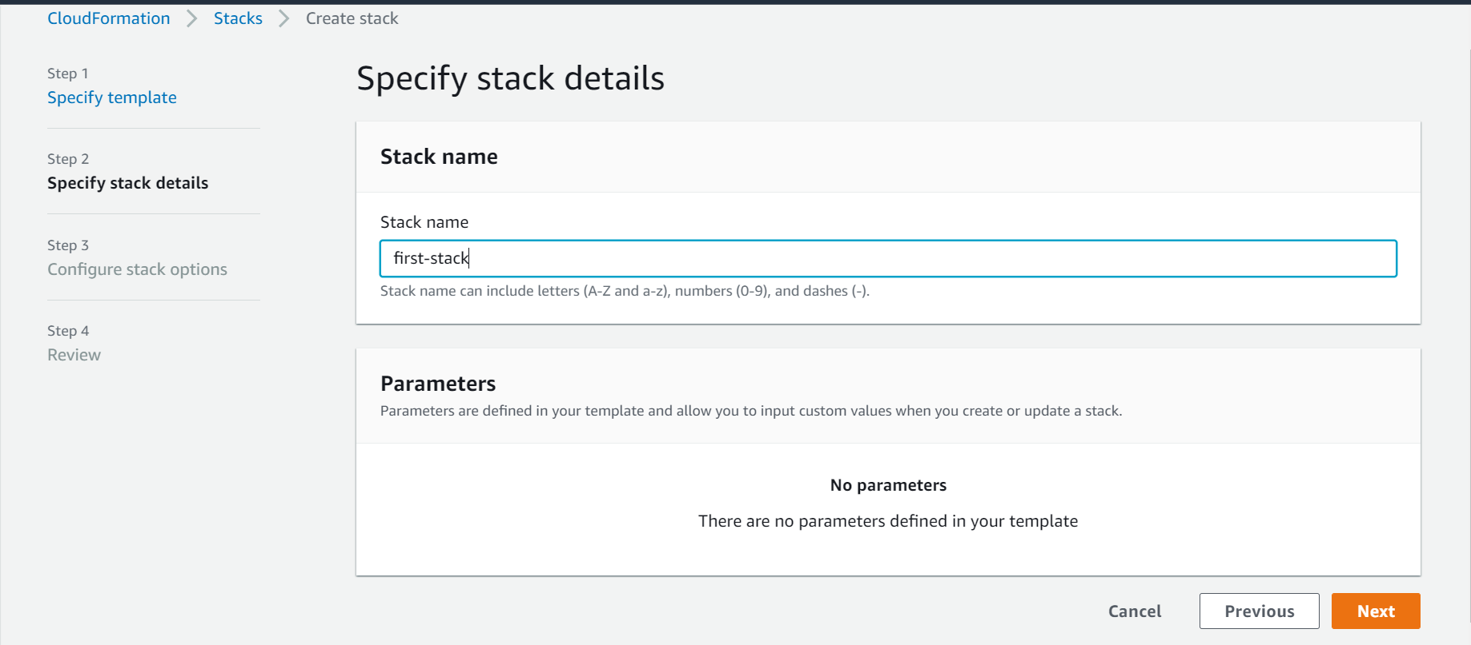

**Step4)Click next**

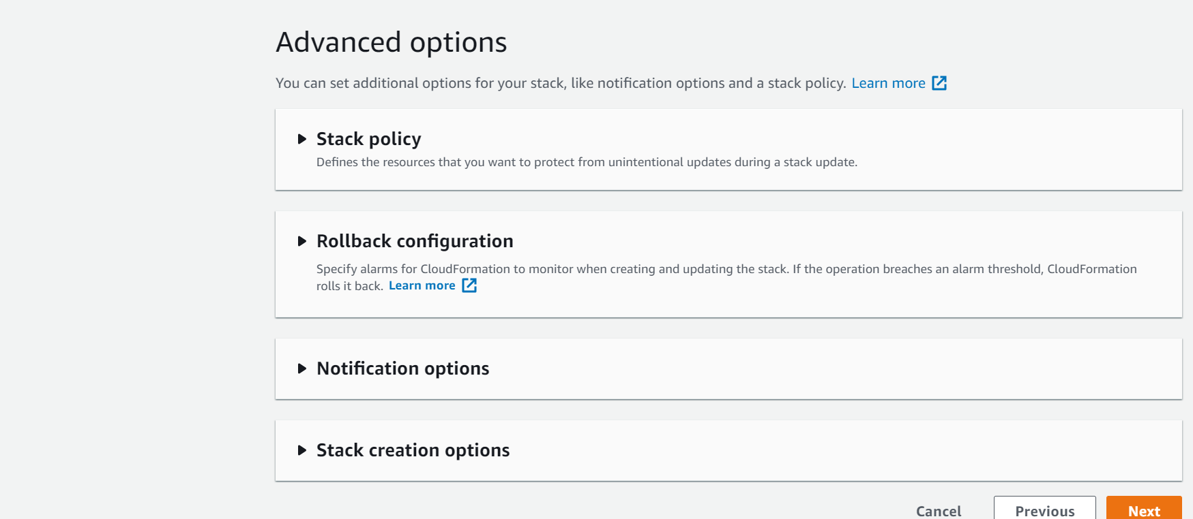

**Step 5) we have template url now just click create stack**

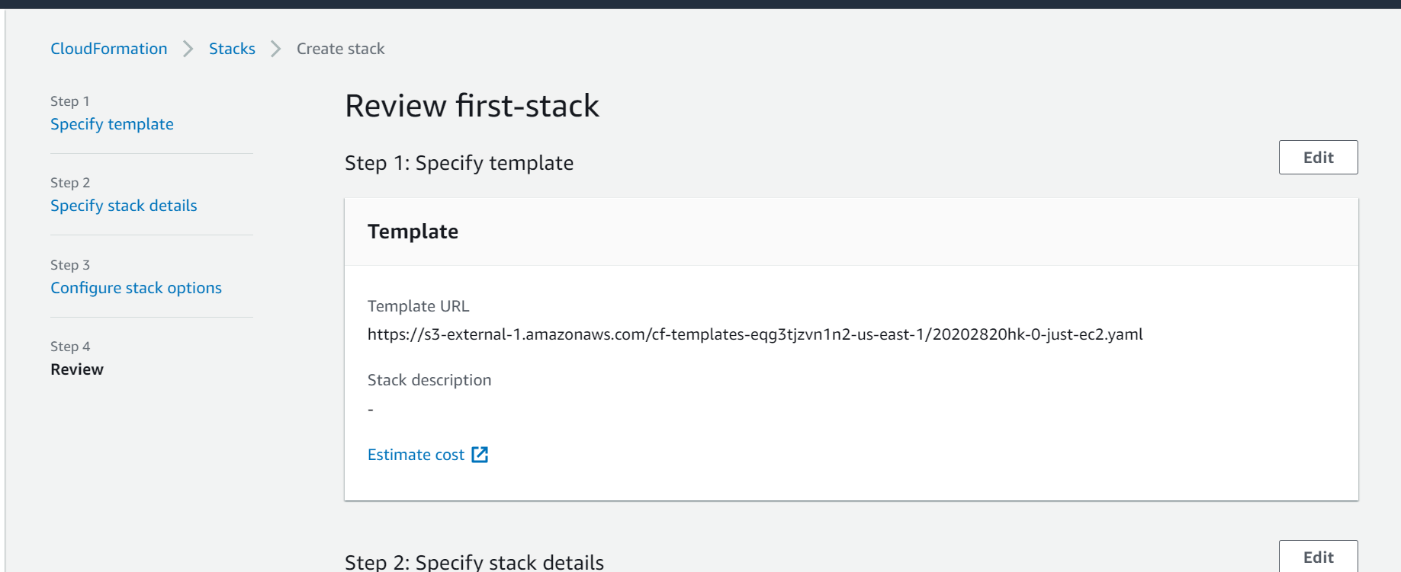

**Now we are in event state that means my ec2 instance is created**

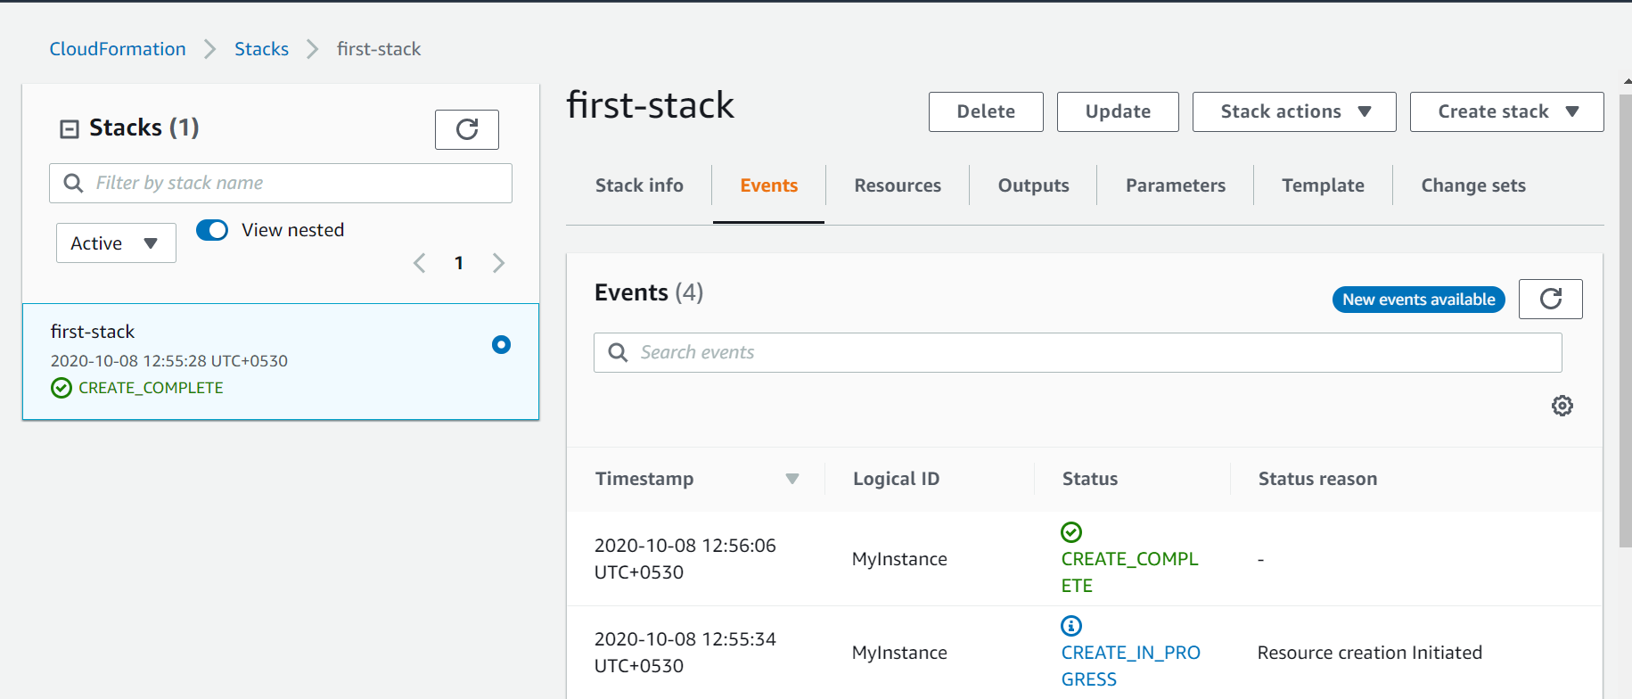

**Now ec2 instance is created**

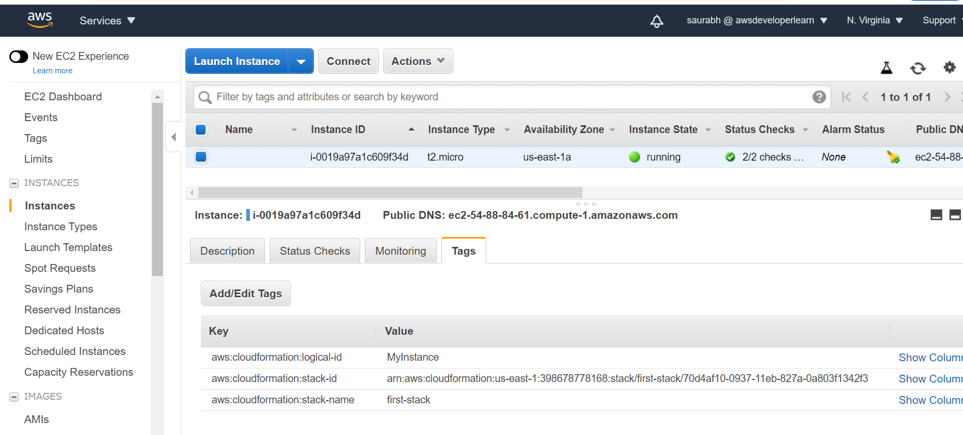

**This means cloud formation stack successfully created ec2**

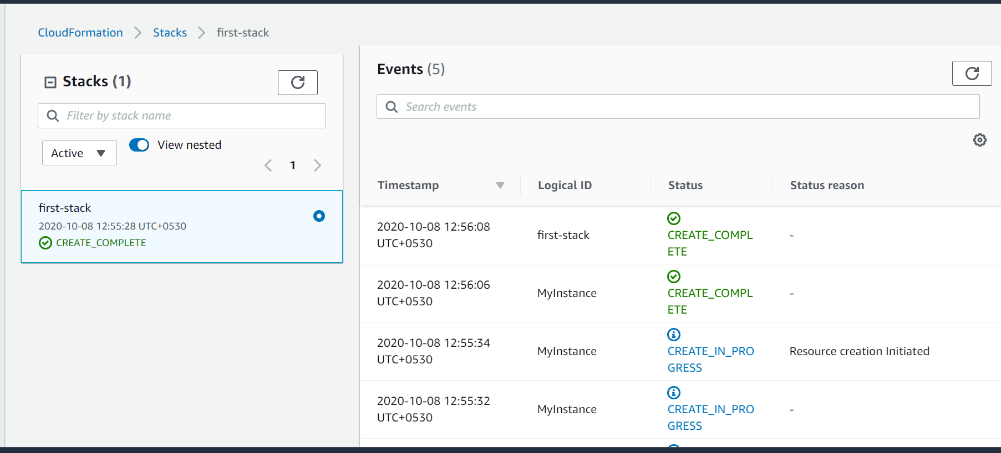

**Note :**

**In resources we have direct link of ec2 instance**

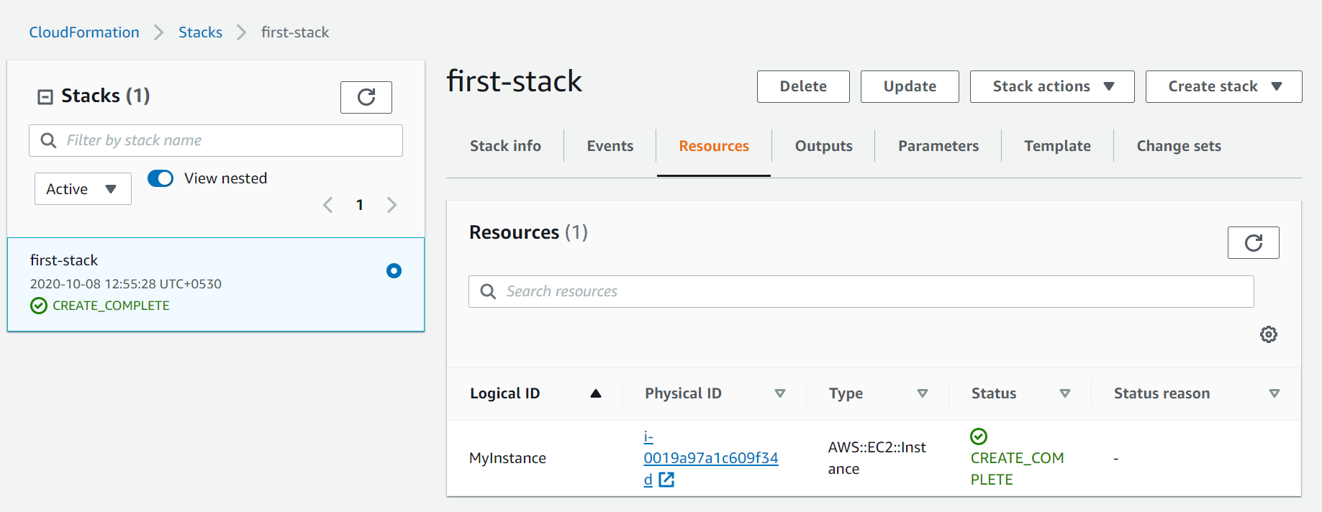

**Template and click view in designer to look cloud formation template**

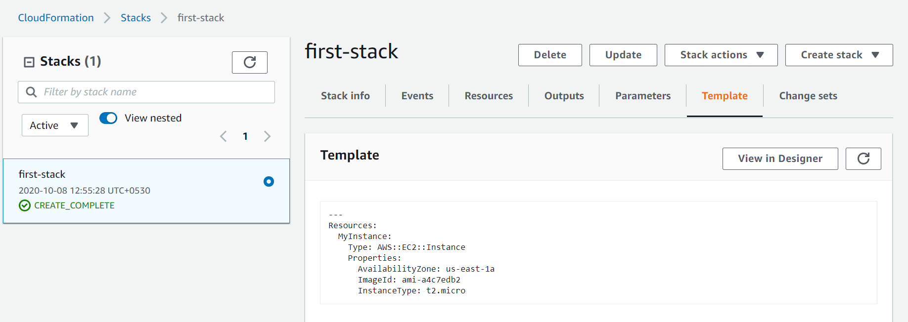

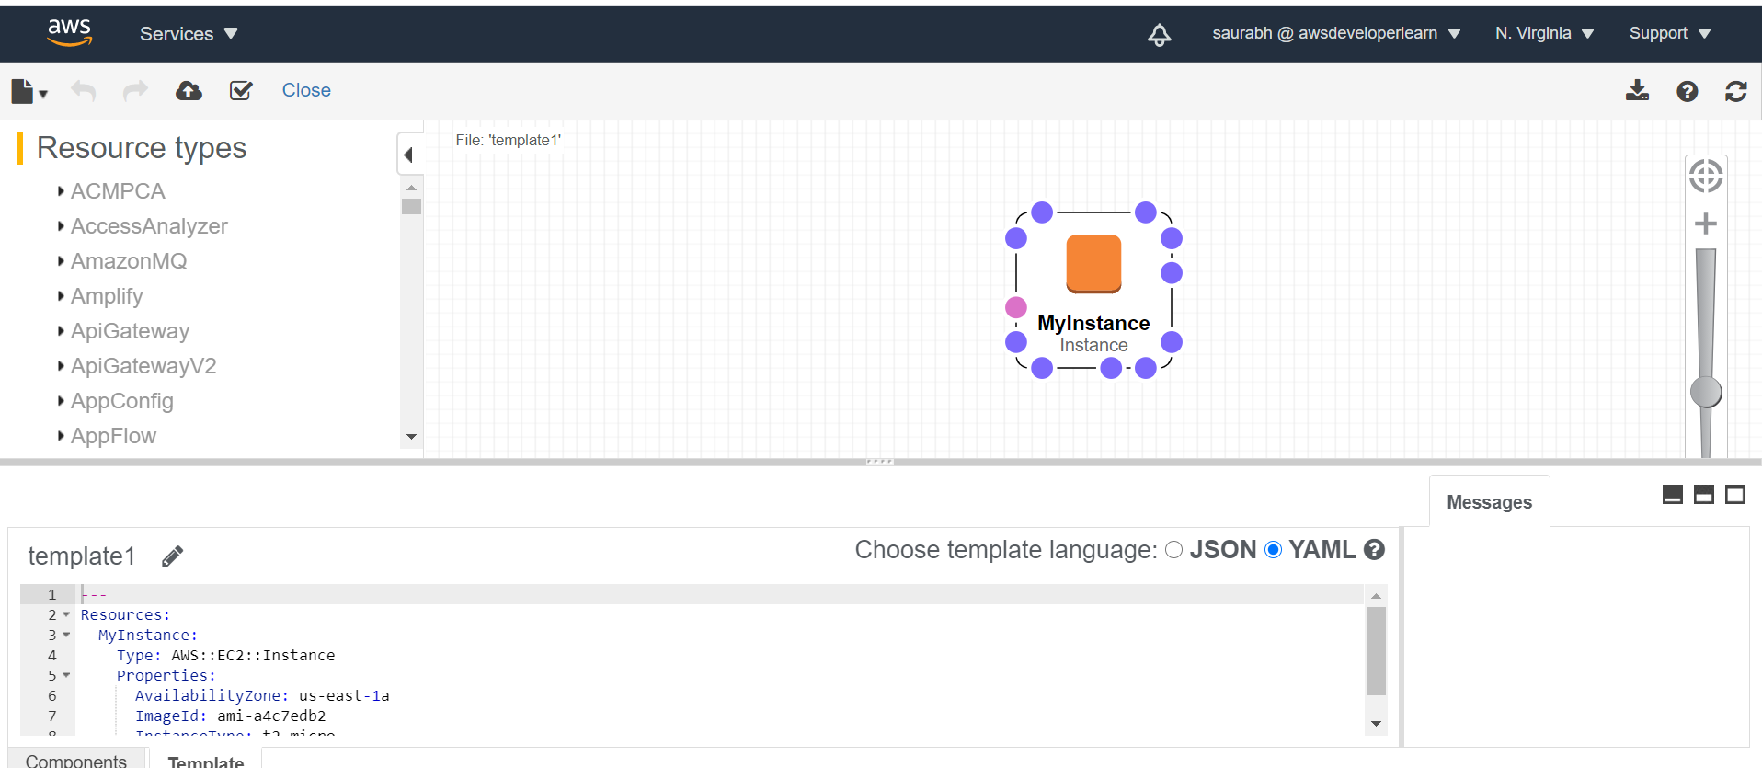

**Cloud formation update and delete stack hands on**

**step 1)Click on update:**

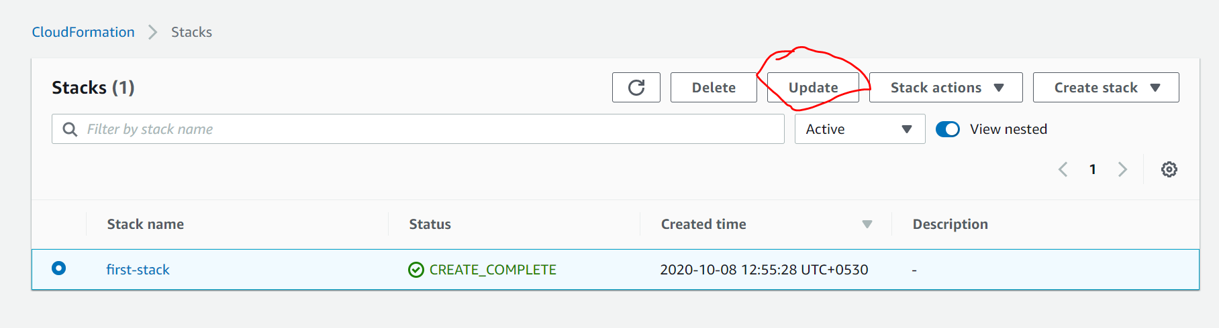

**Step 2) replace current template and upload n new file**

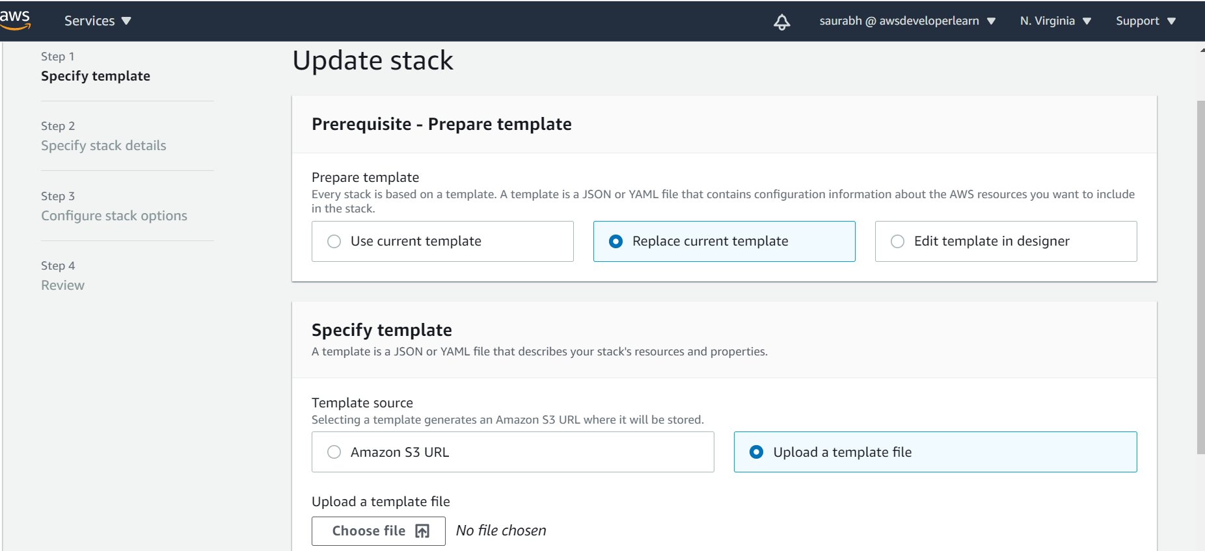

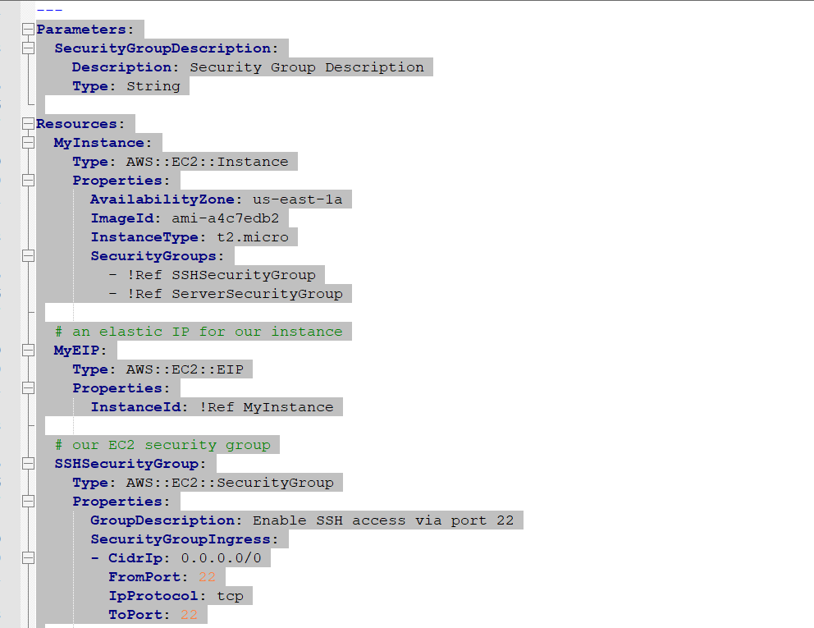

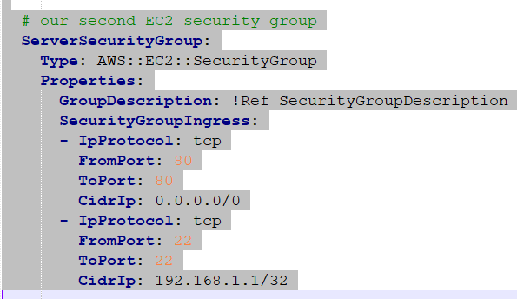

**Step 2) click next**

**Now I will get prompting security group**

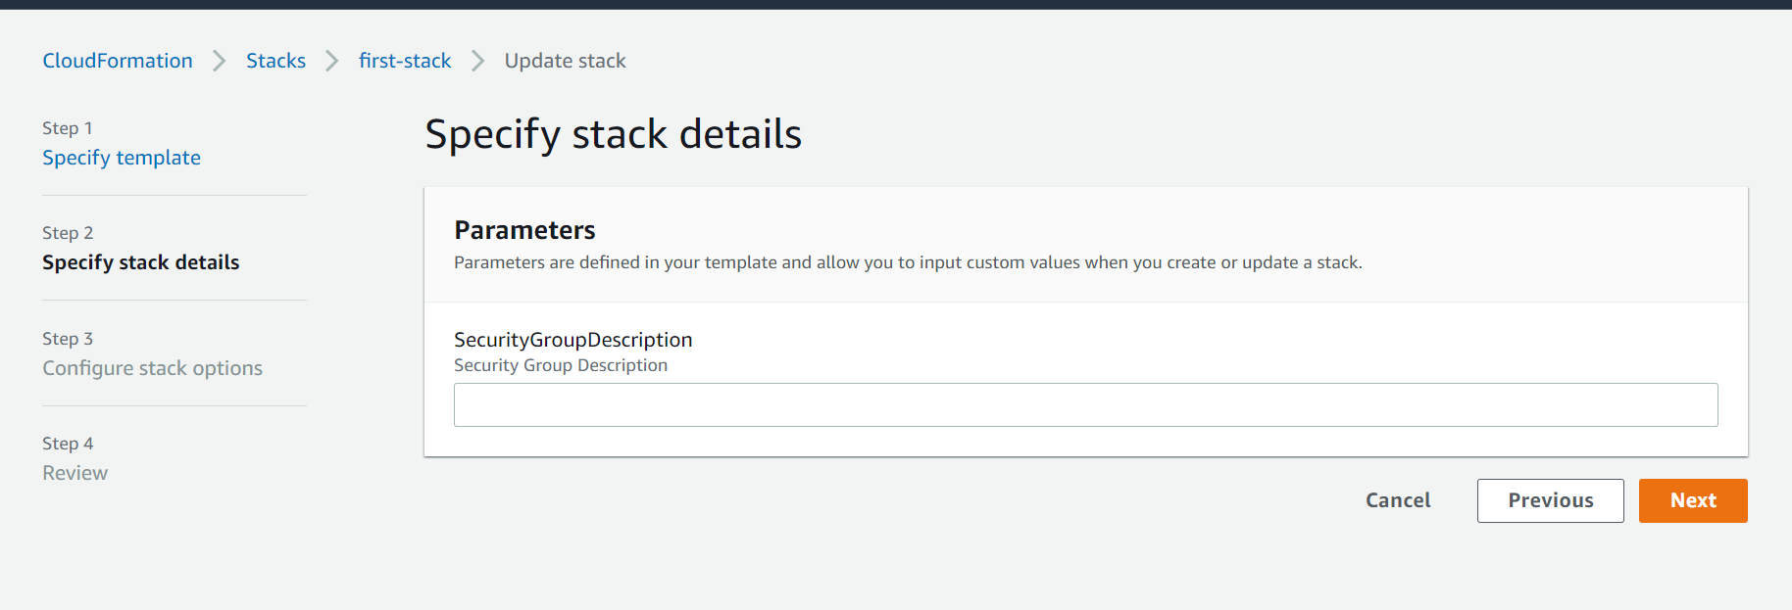

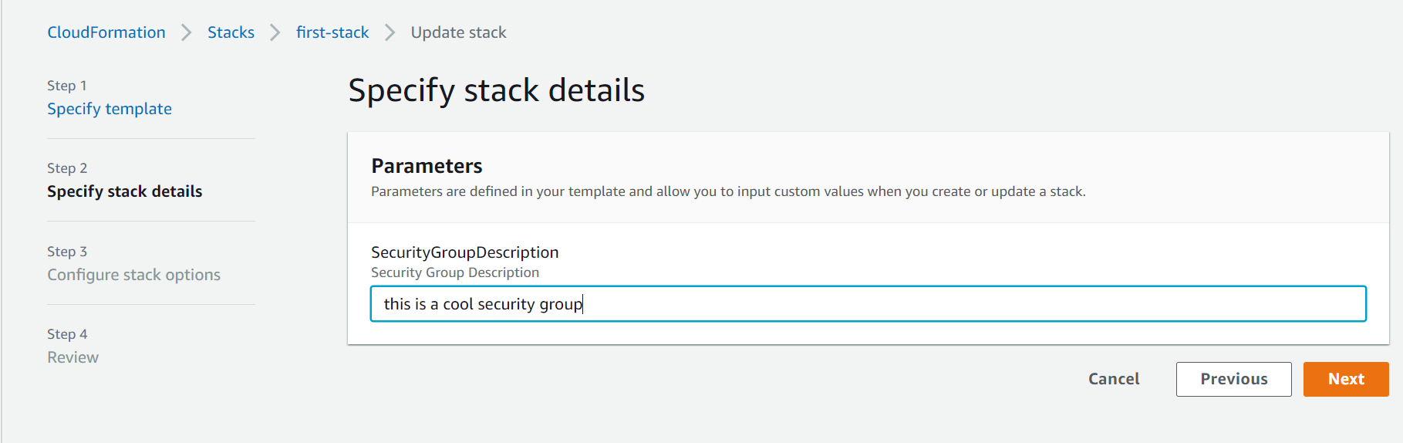

**Click next**

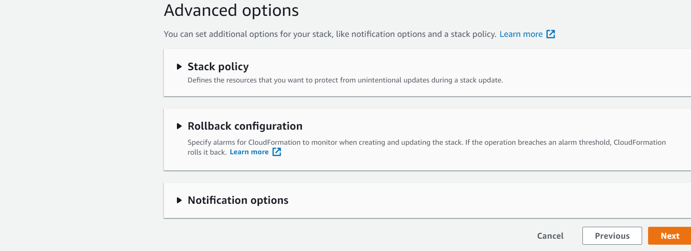

**Step 4)**

**This will tell what is newly added in template and what is modified**

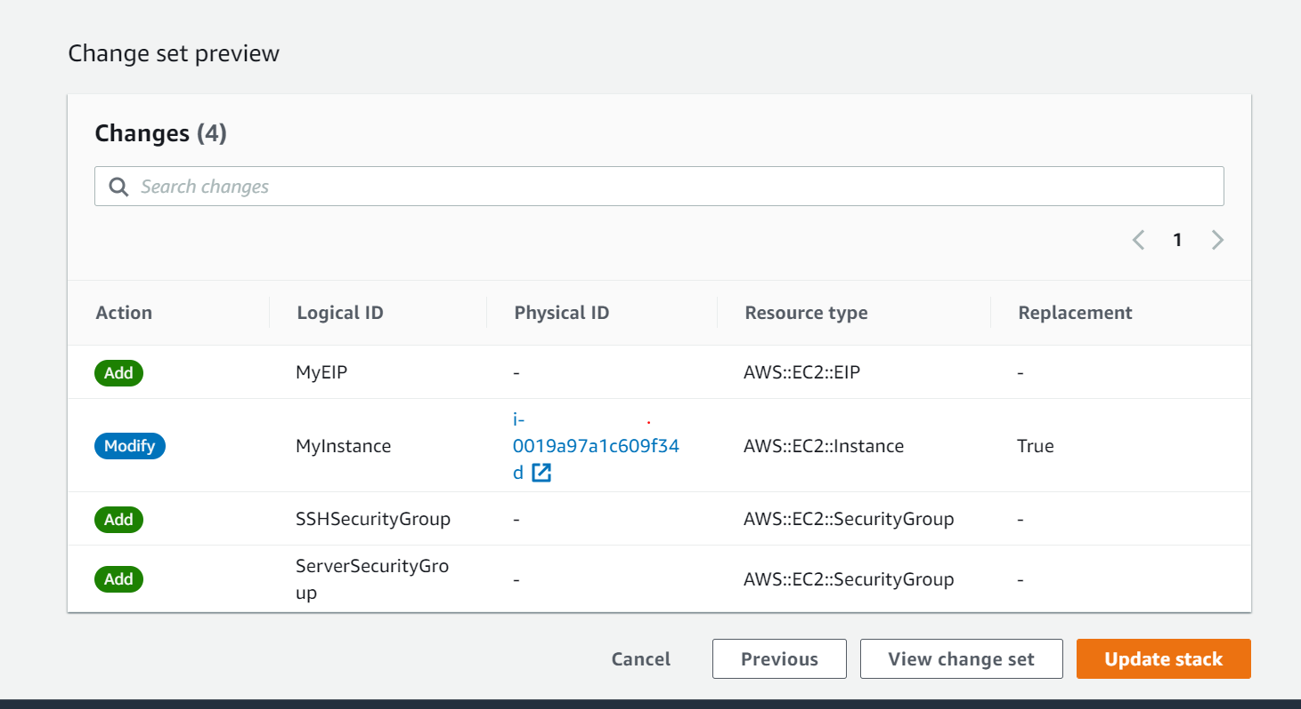

**NOTE:**

**Important point : even if we didn’t mention order in template cloud formation is intelligent what we need to execute first**

**ex:**

**First it will create ec2 instance then security group**

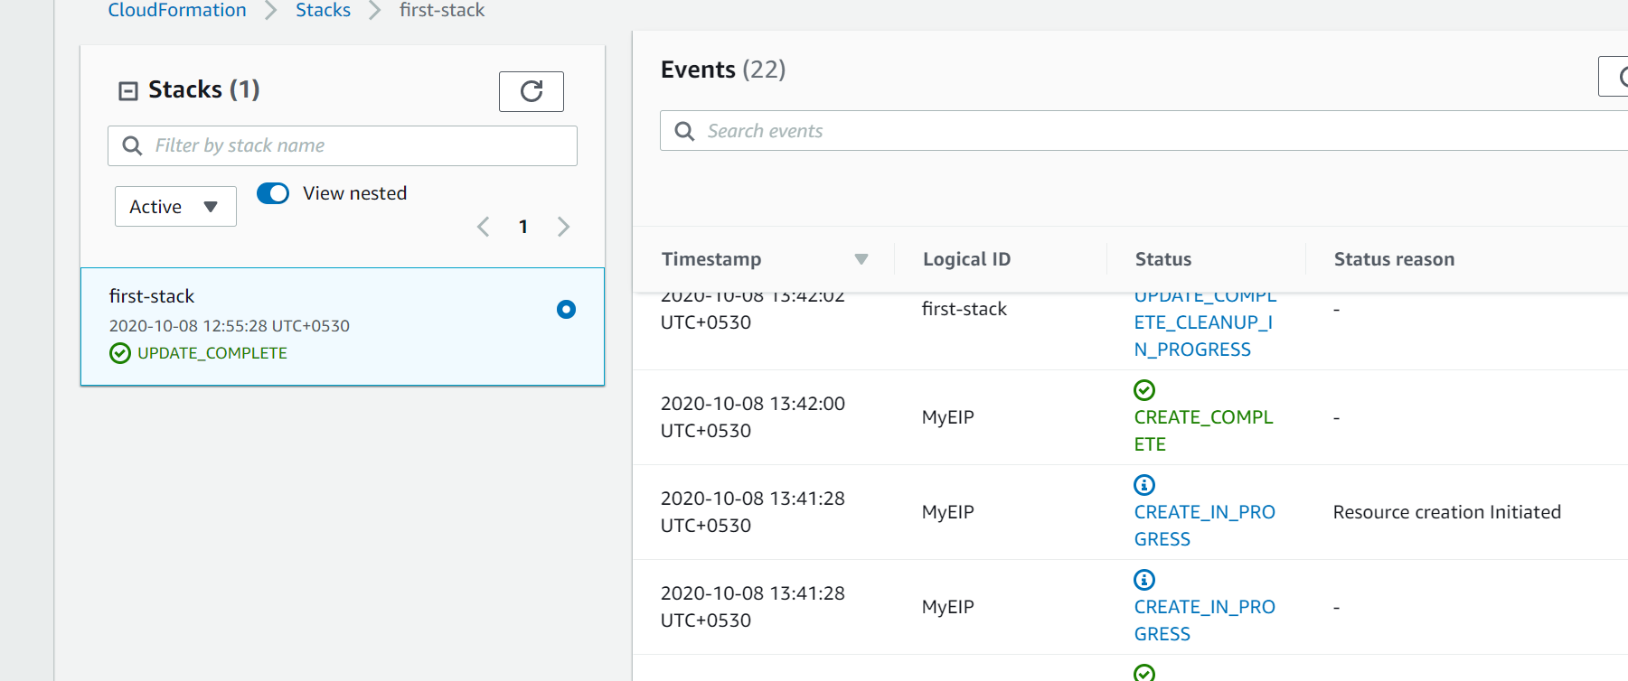

**As soon as updation is complete previous ec2 instance will be terminated**

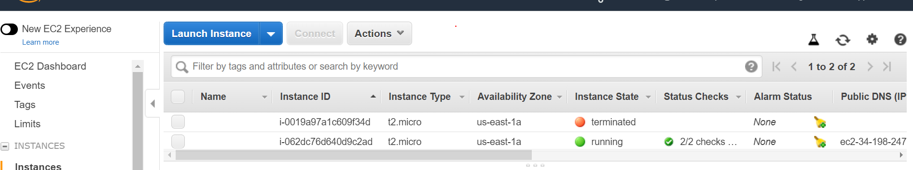

**In resources :**

**It will tell everything what we have**

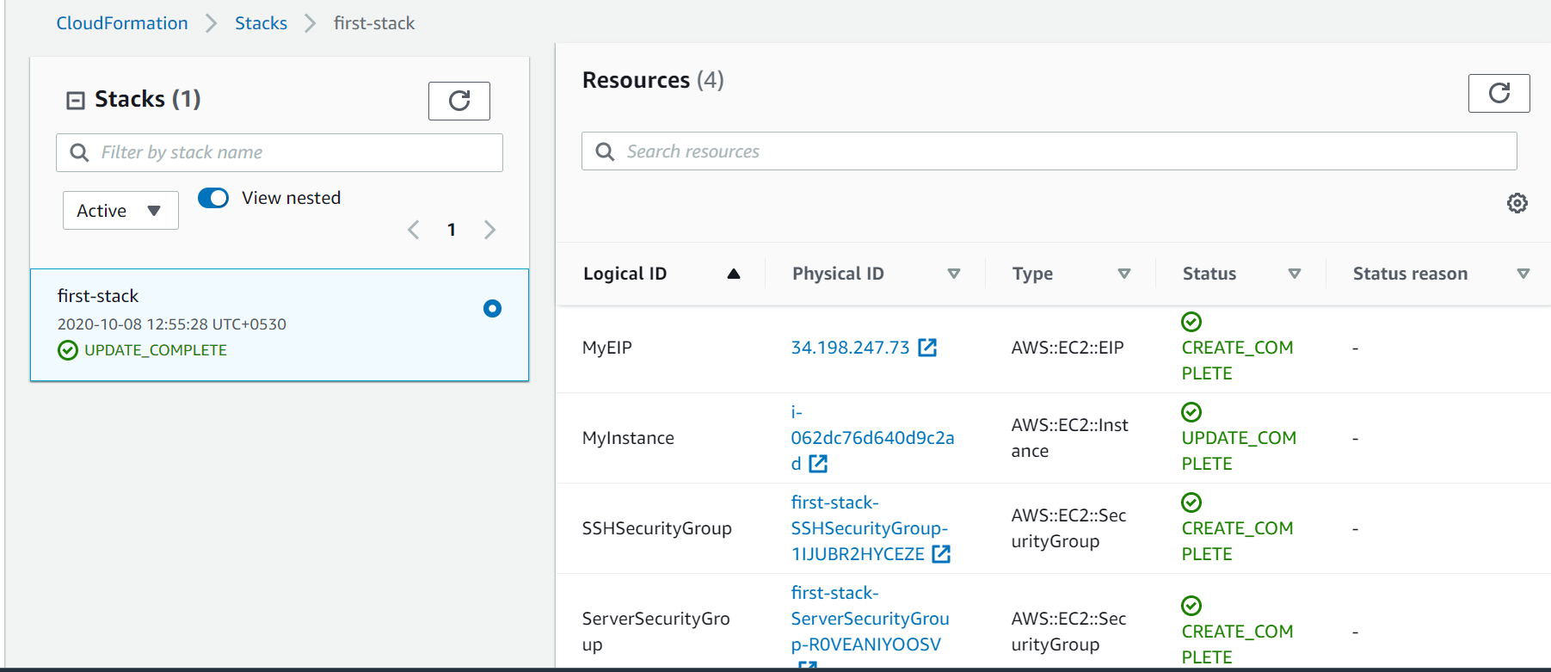

**Security group and elastic ip both will linked to ec2**

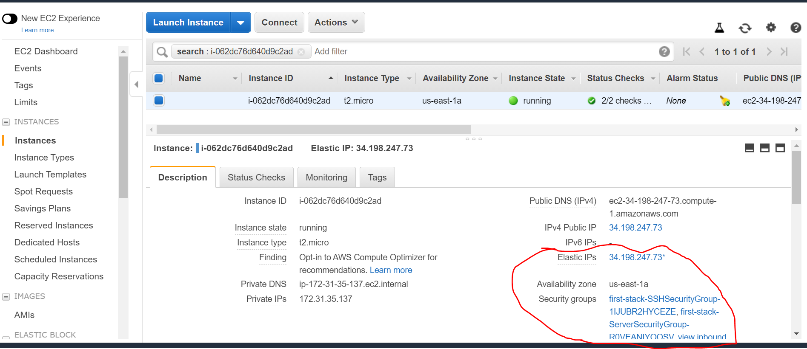

**See description**

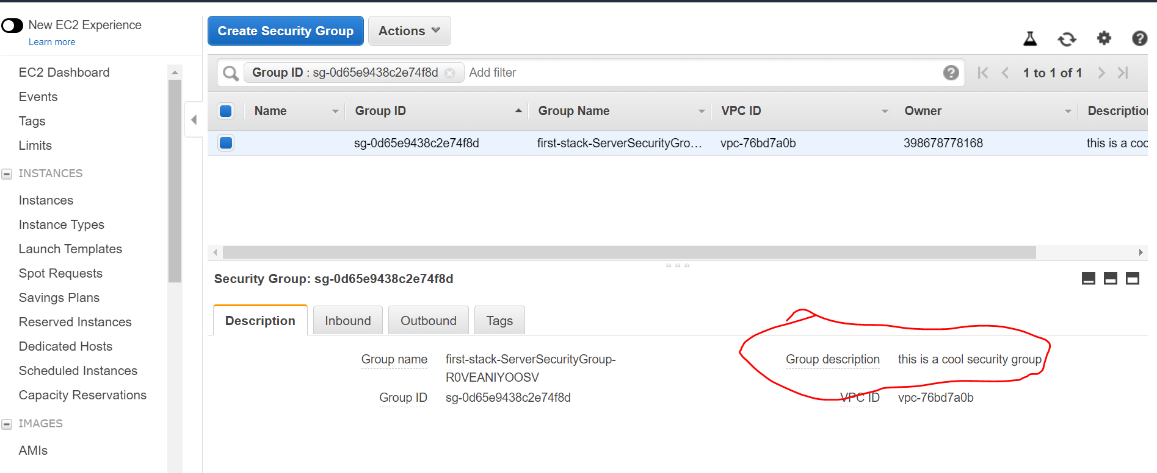

**That means parameter we define while creating in cloud formation was applied to security group description**

**Note :**

**When we delete cloud formation it knows what to delete first**

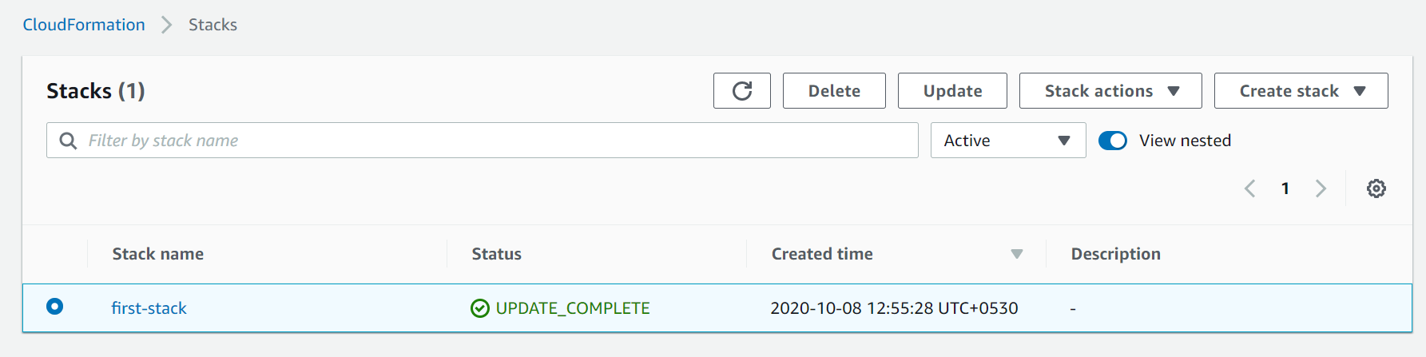

**Yaml crash course**

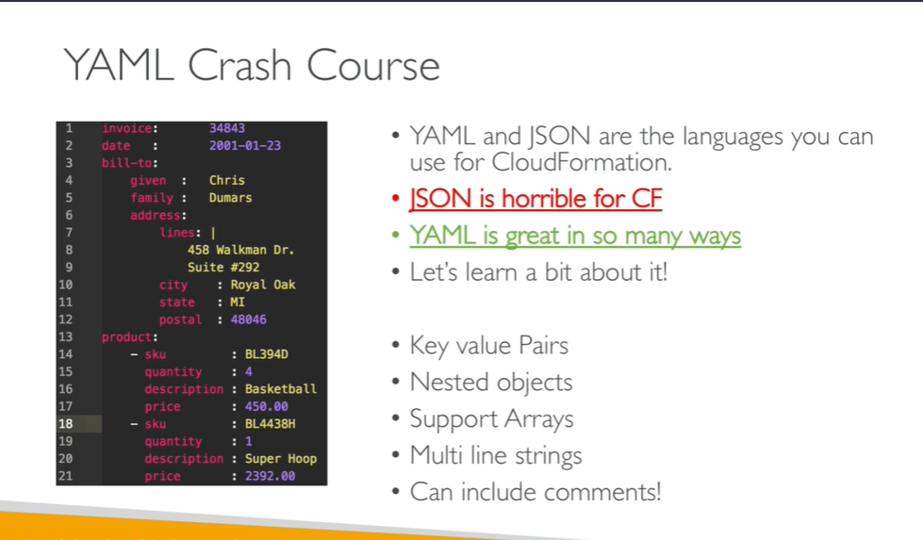

**Cloudformation resources**

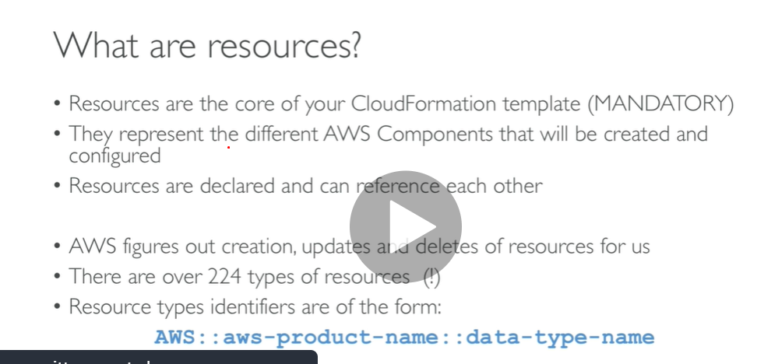

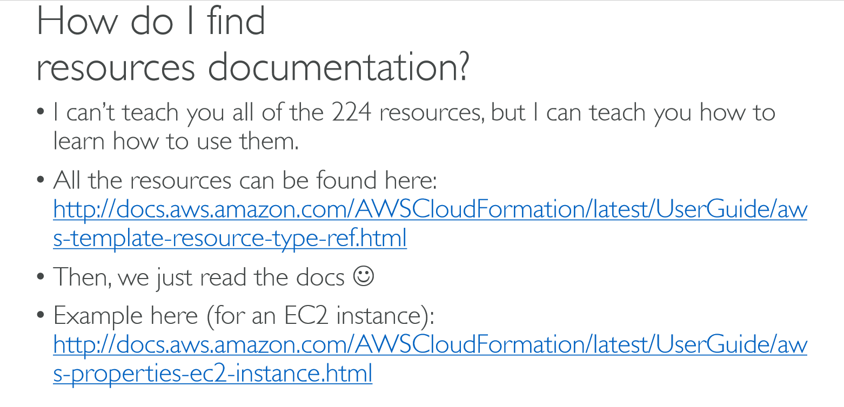

**Resource template link**

<https://docs.aws.amazon.com/AWSCloudFormation/latest/UserGuide/aws-template-resource-type-ref.html>

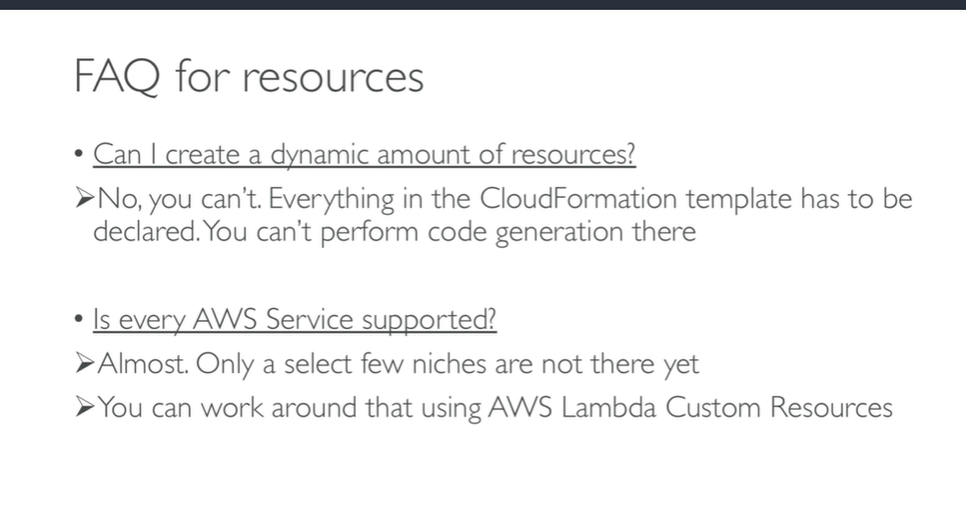

Cloud formation parameter

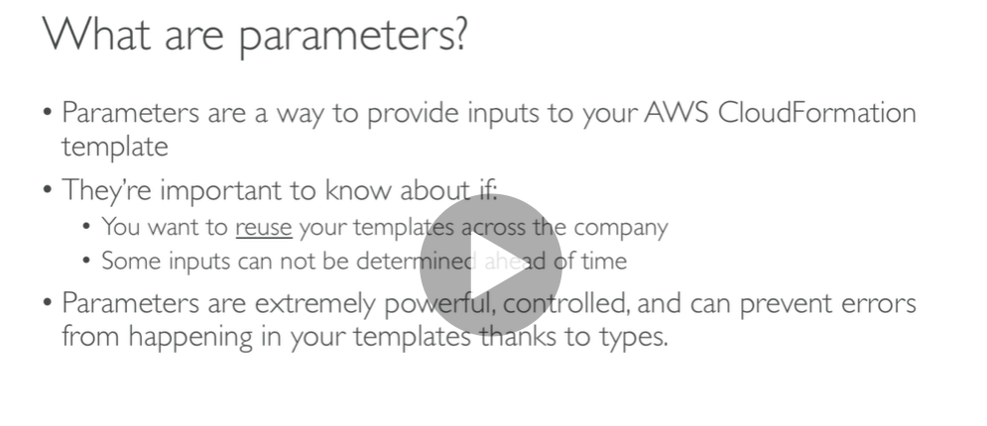

Note :

**by using a parameter we don’t have to upload template again**

**If value can be change then we have to use parameter**

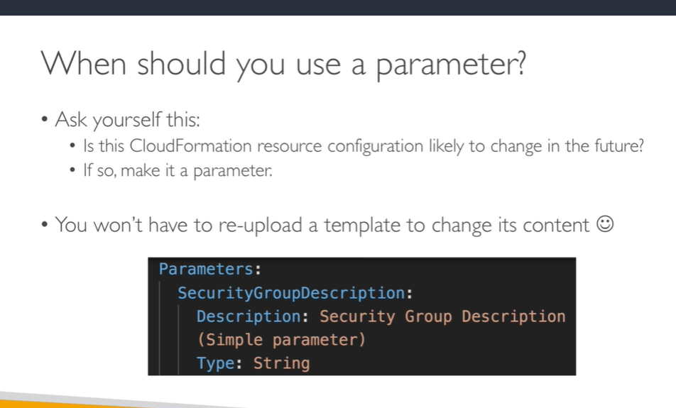

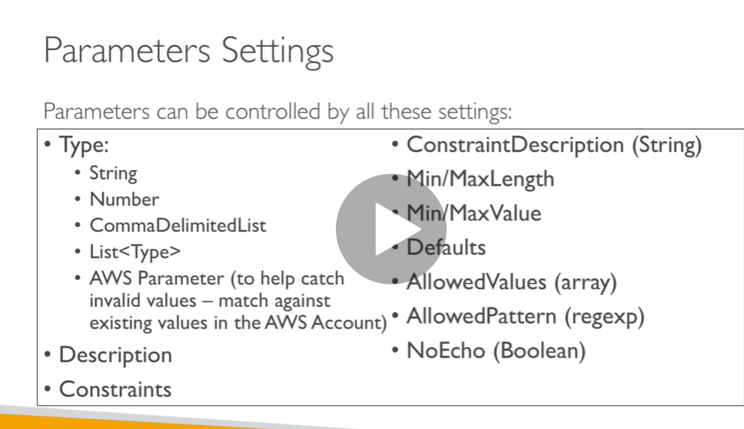

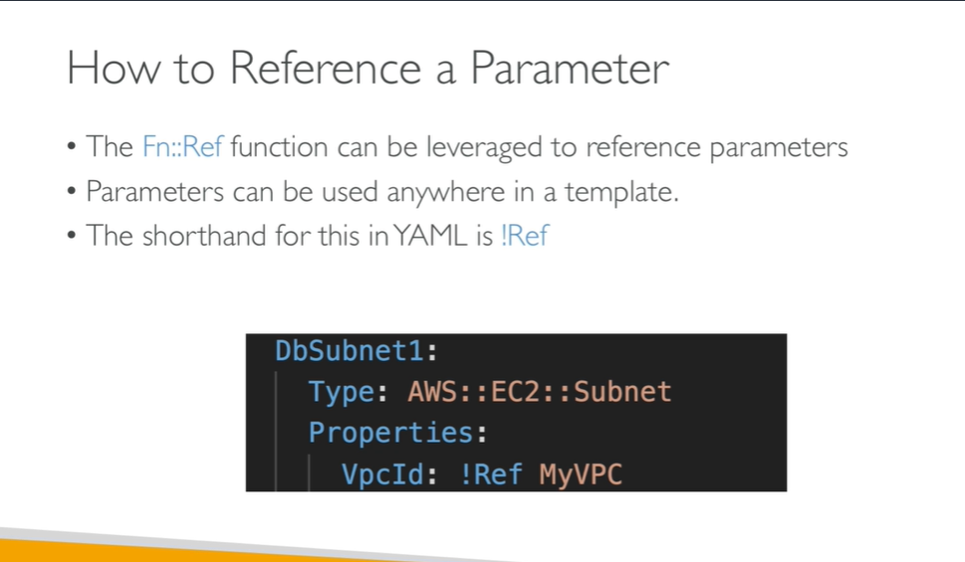

**Note :** in our demo we use SecurityGroupDescription as ref

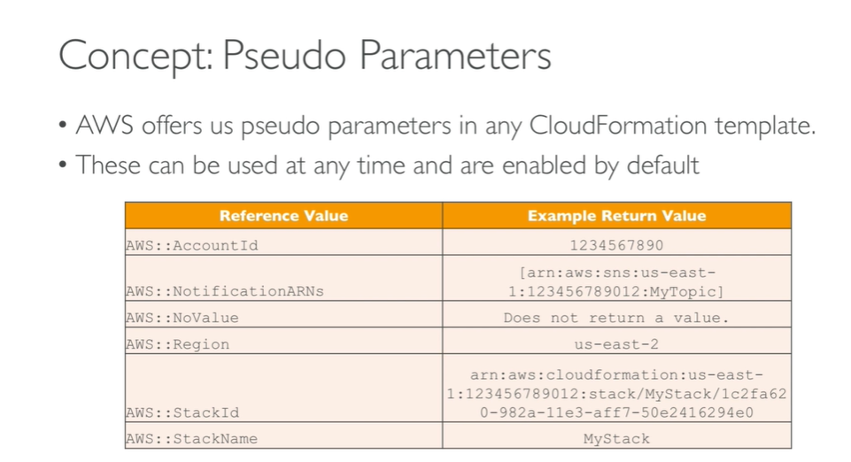

Cloud formation Mappings

Value are hardcoded

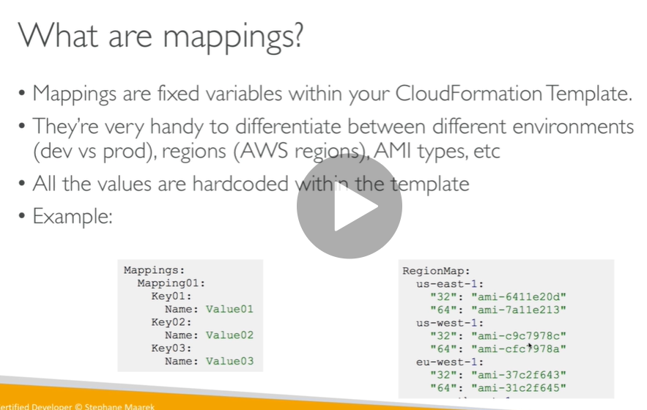

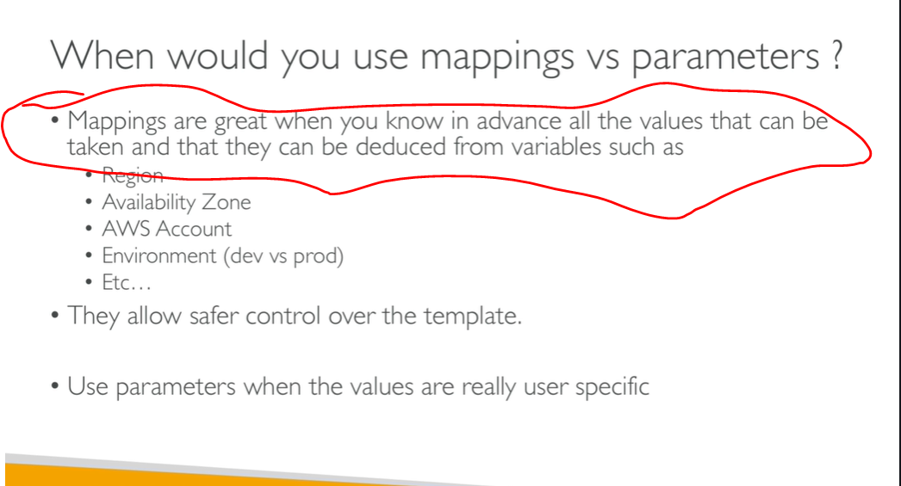

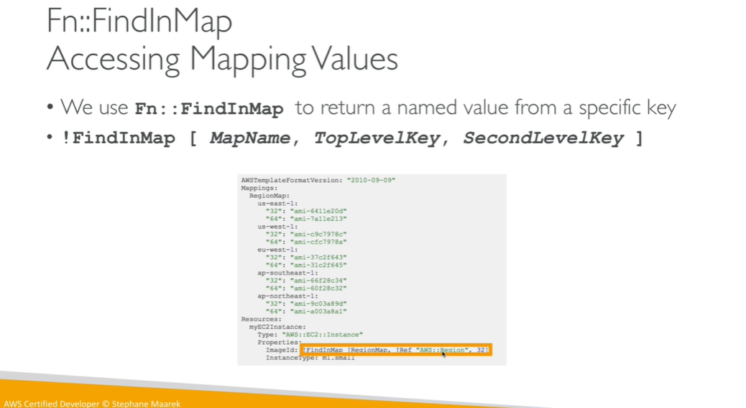

**Map name : region map**

**Top level key: us-east-1**

**Second level key: 32**

**Cloud formation output**

**Note : we cant delete a cloudformation template if output is referenced**

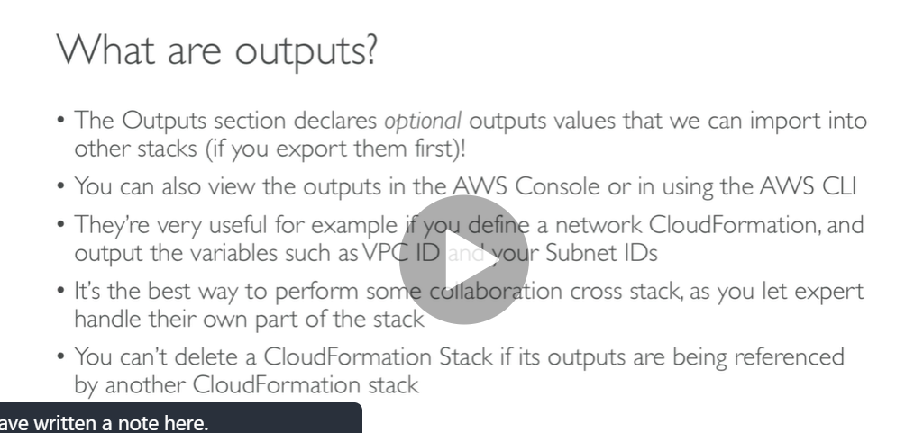

Note : we can link cloud formation template value from one to another

**Note security group will be export by name sshsecuritygroup**

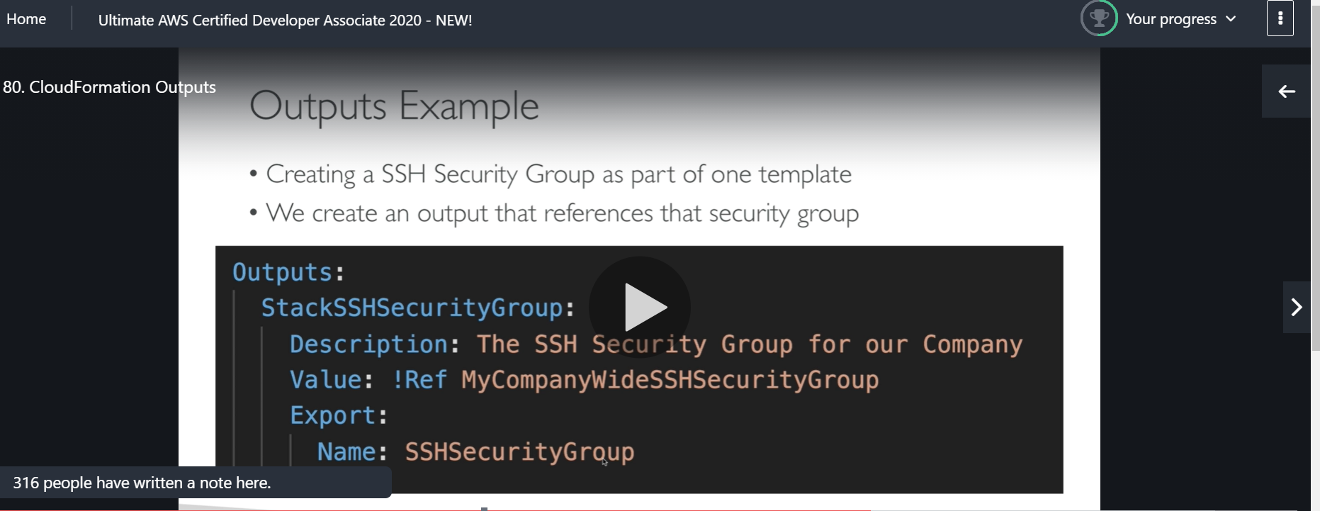

**How we will import now security group**

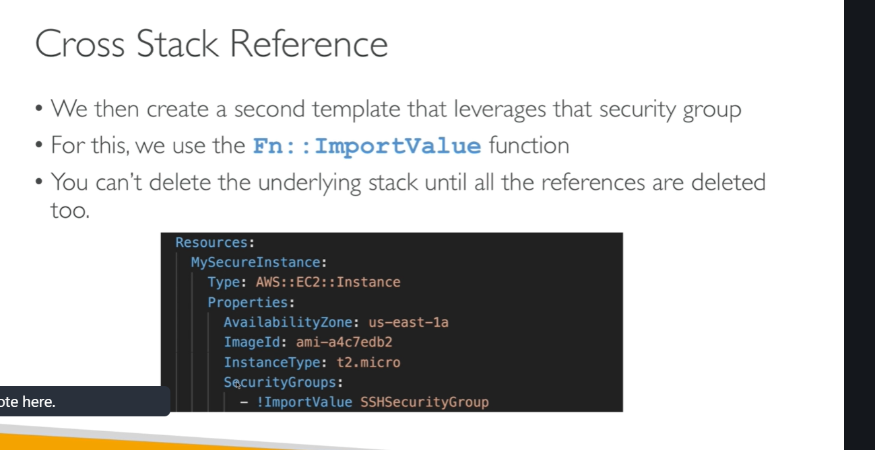

**Cloud formation condition**

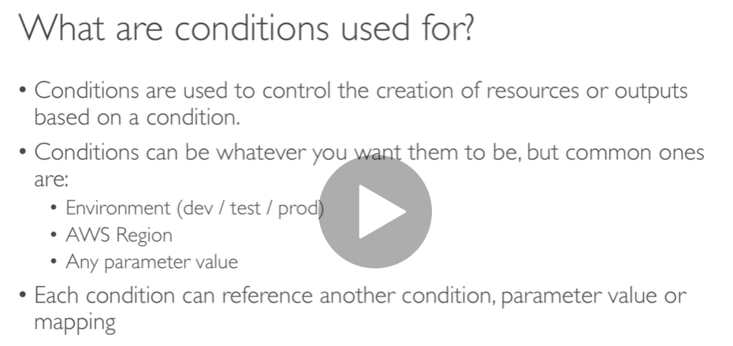

**Note : condition will be true only when envtype is prod**

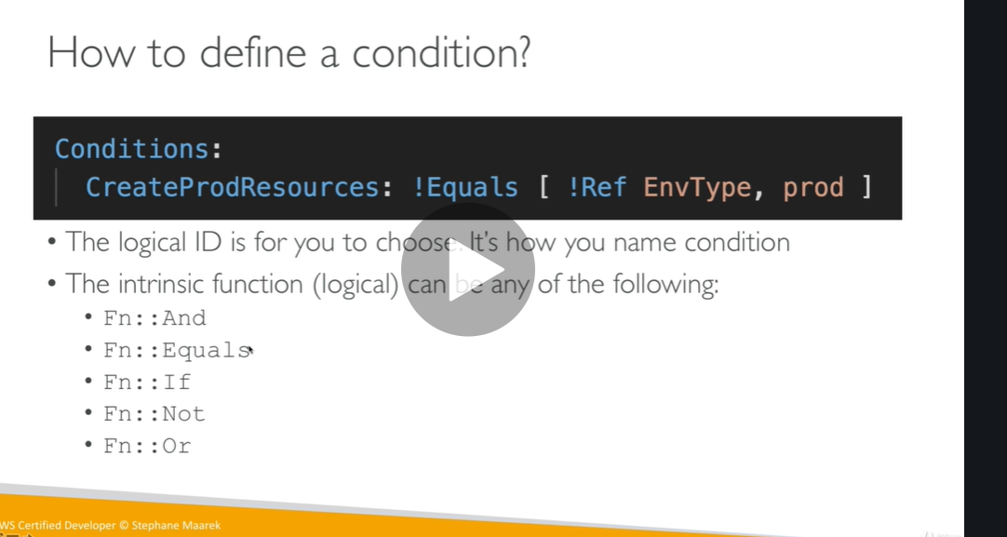

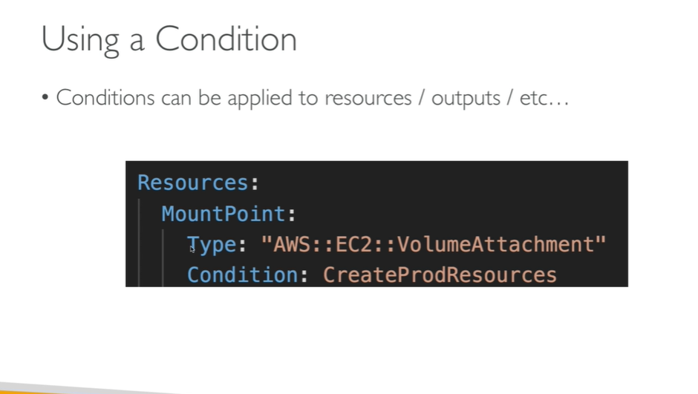

**Cloud formation Intrisic function**

**Very important need to know**

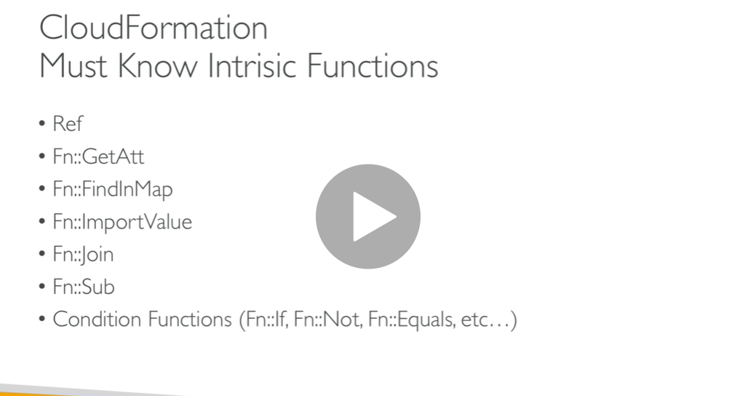

**Note : when we reference a resource it returns a physical id**

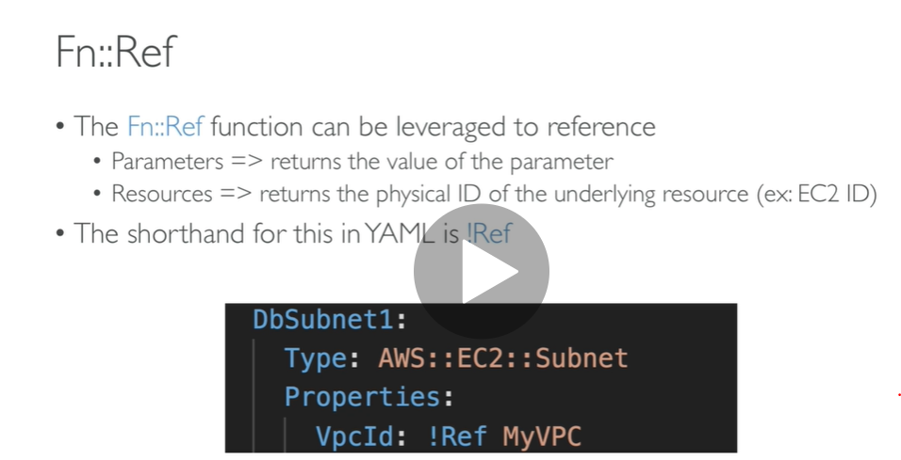

**How we get other information of resources except id**

**Want to get AZ of ec2**

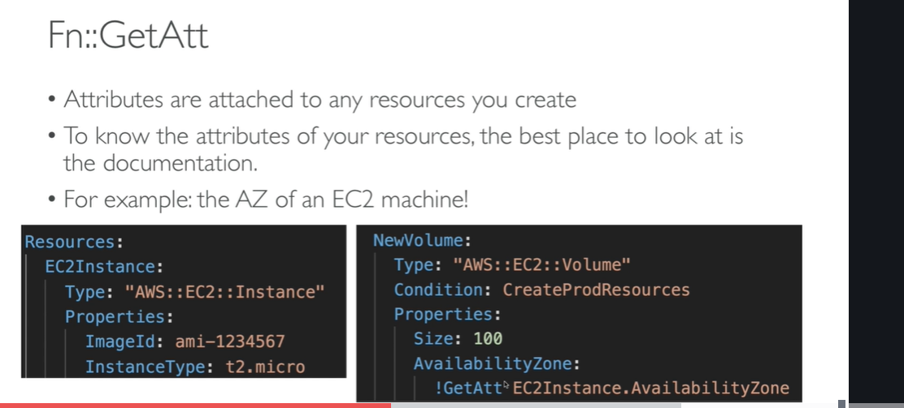

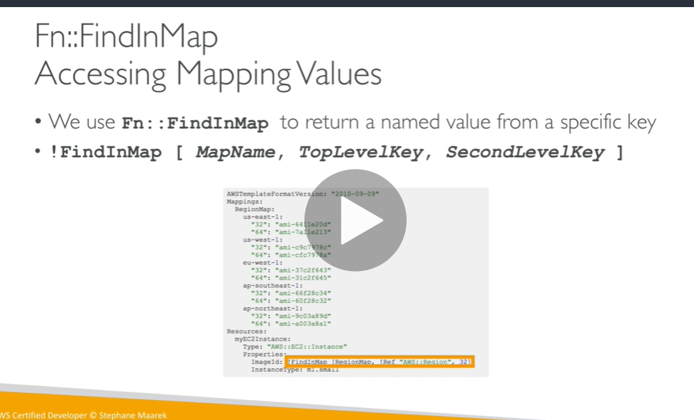

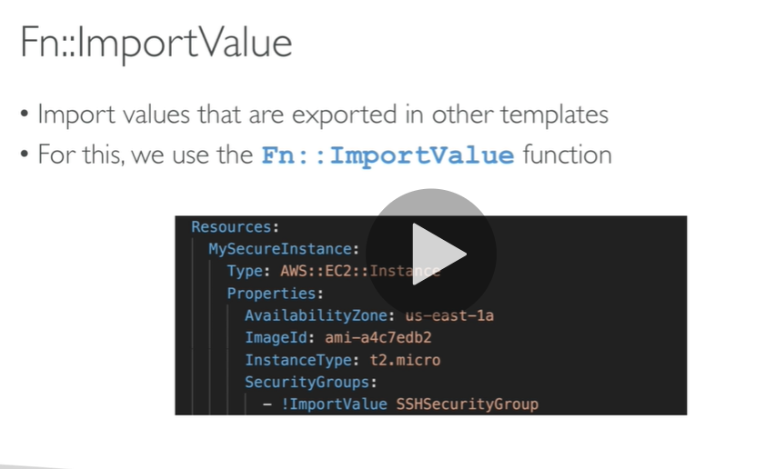

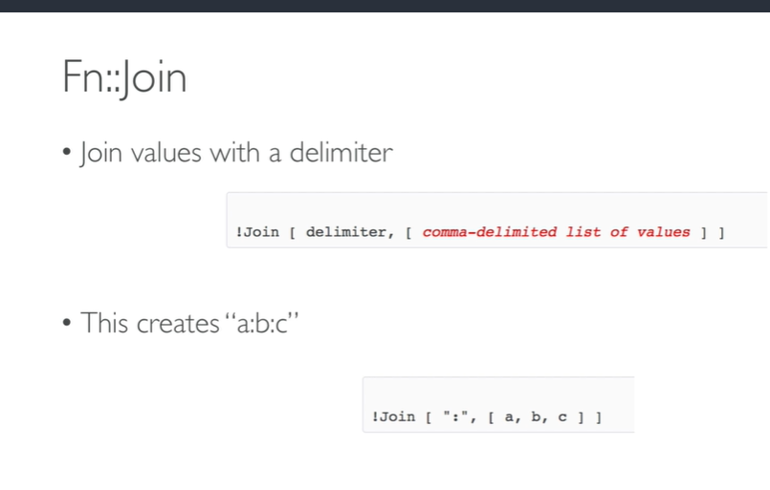

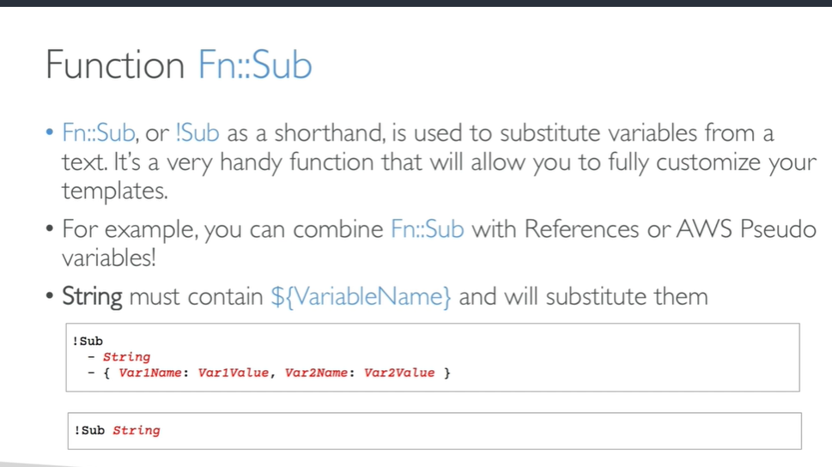

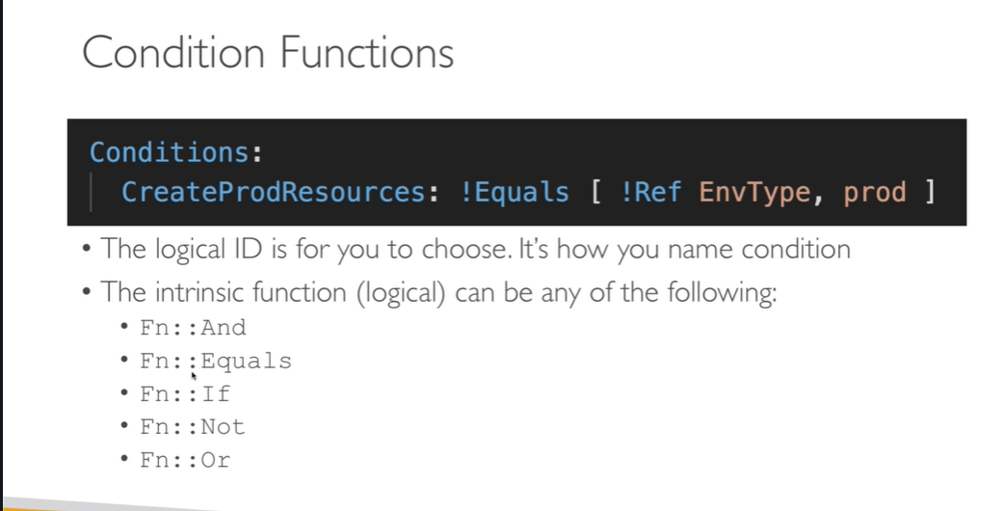

**Cloud formation rollbacks**

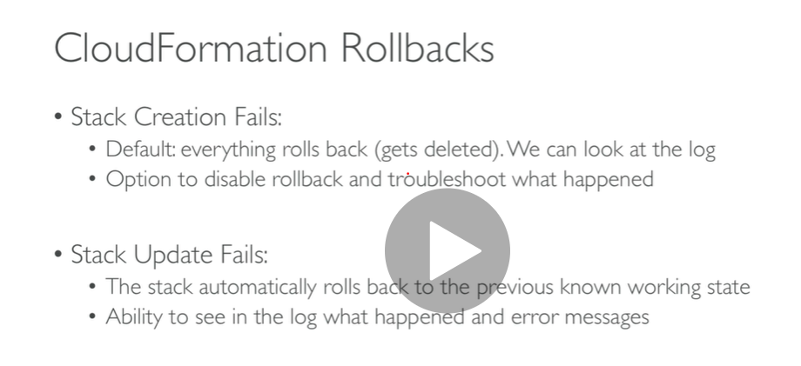

**Hands on**

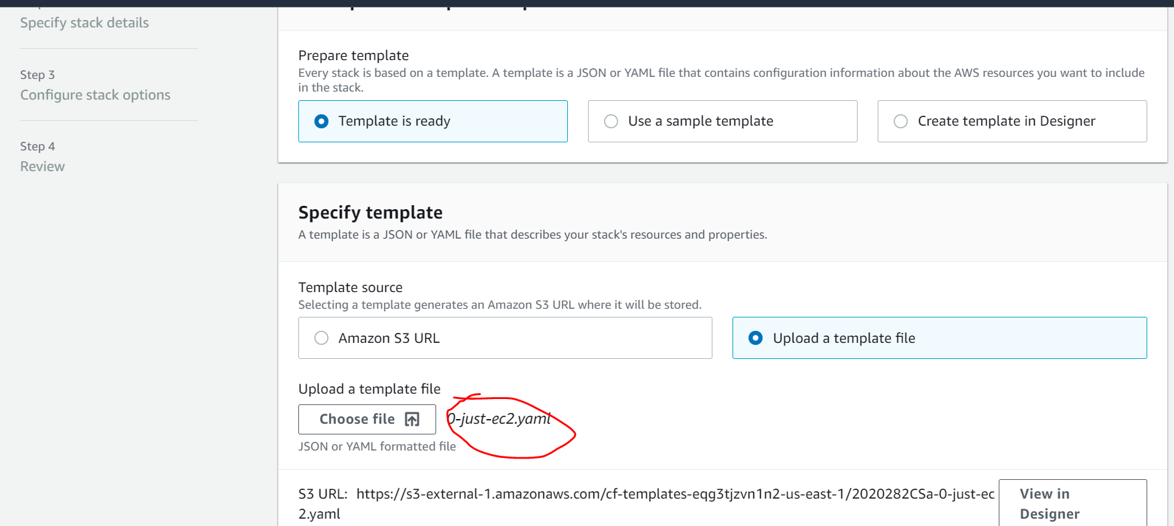

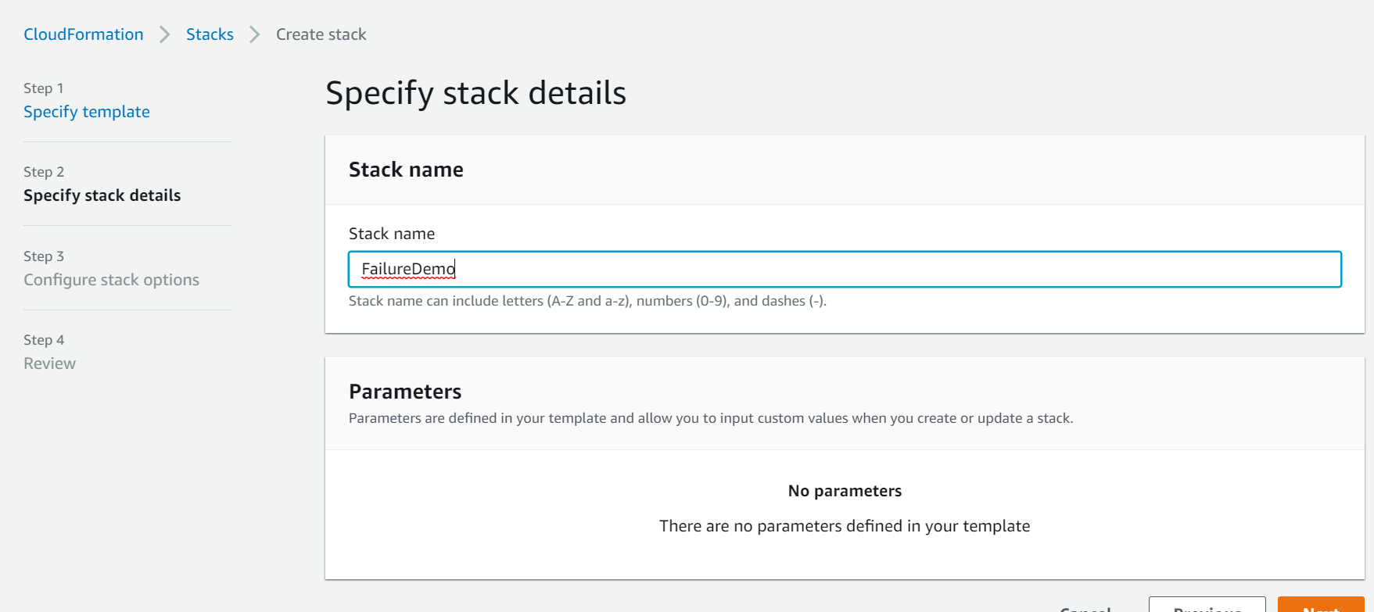

**Next/next/createstack**

**Note : this will create ec2 instance**

**Stack created**

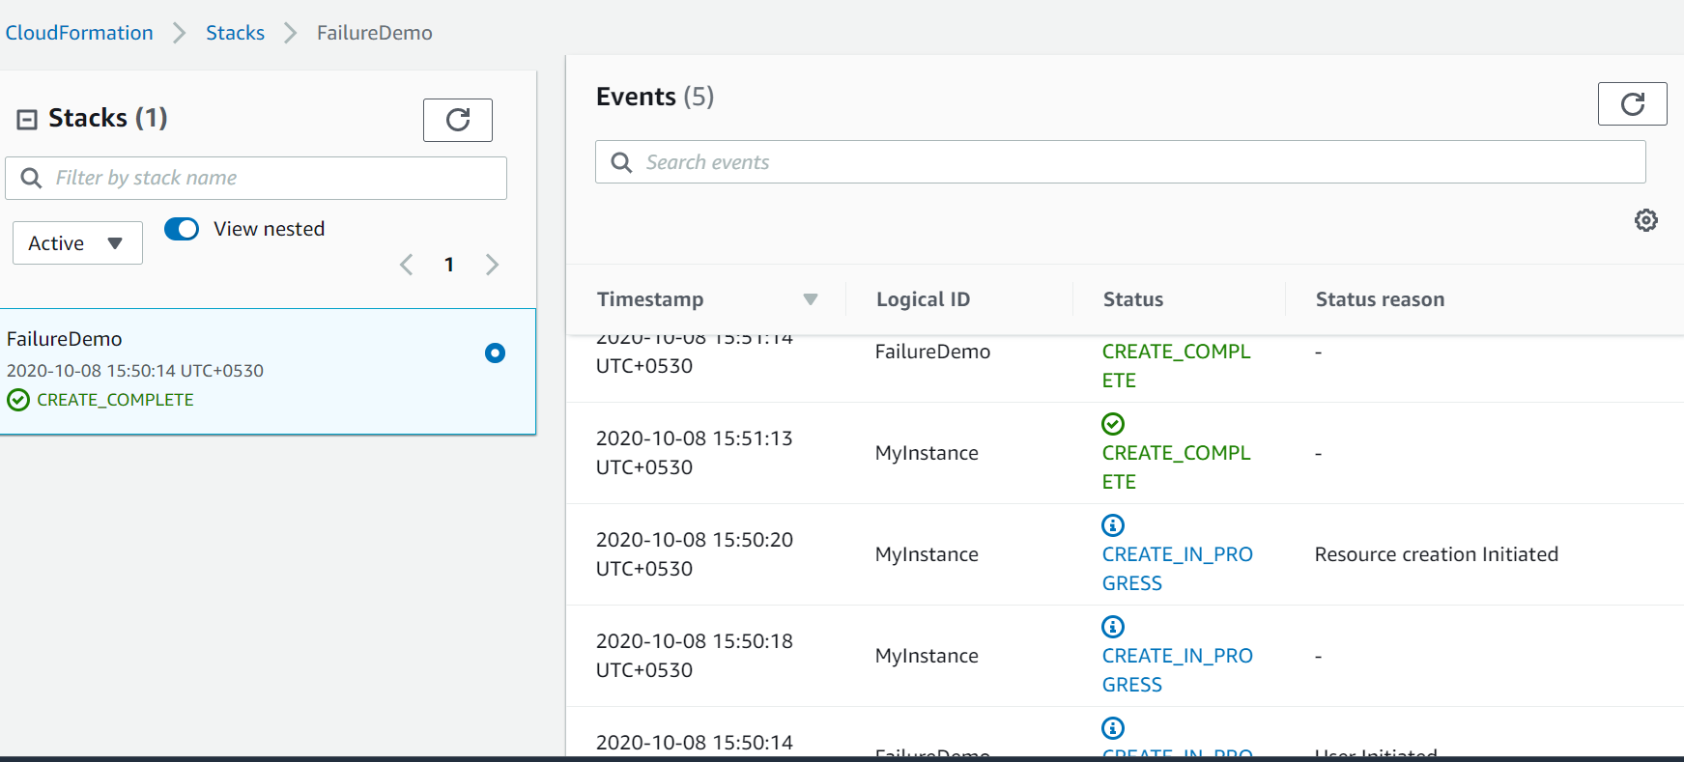

**Upload a new template ( update/replace current template)**

**This time it will fail**

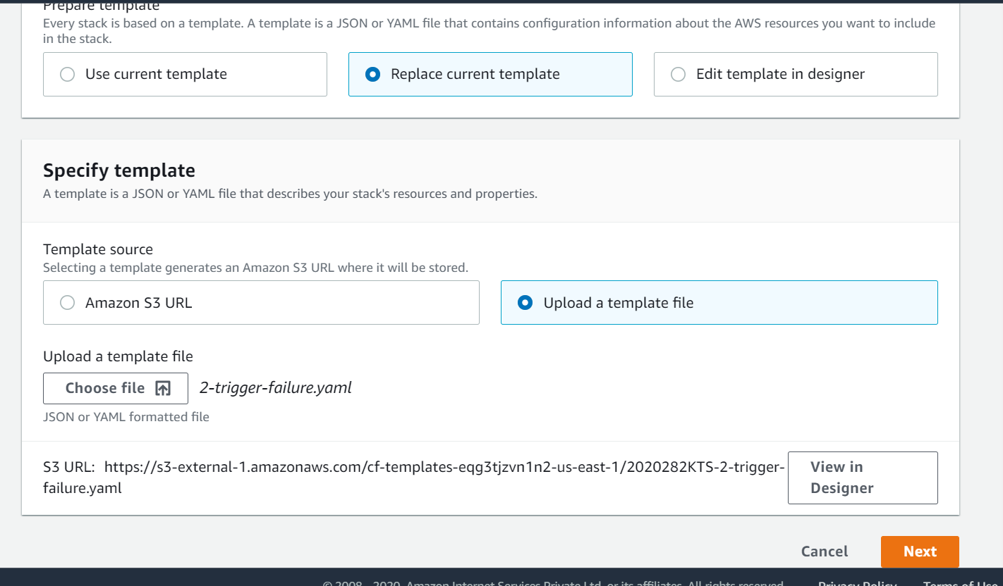

**Hello world security group description**

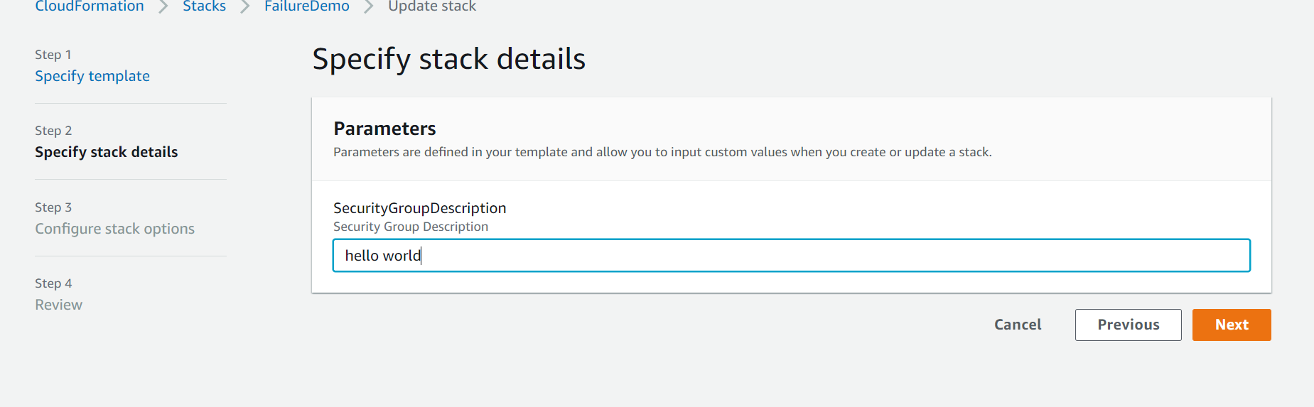

**Next/next/update stack**

**Image id is not exist in this region that’s why it will get fail**

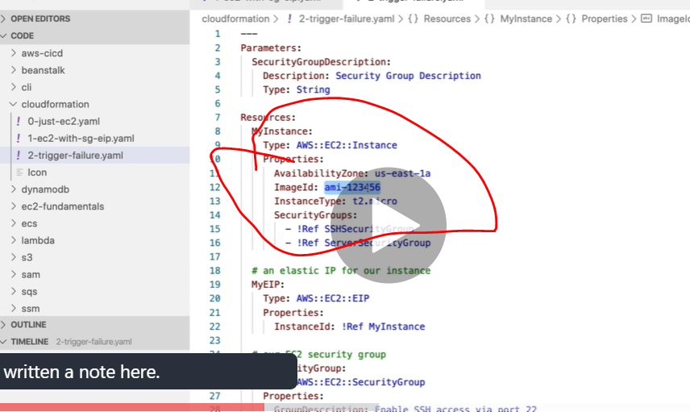

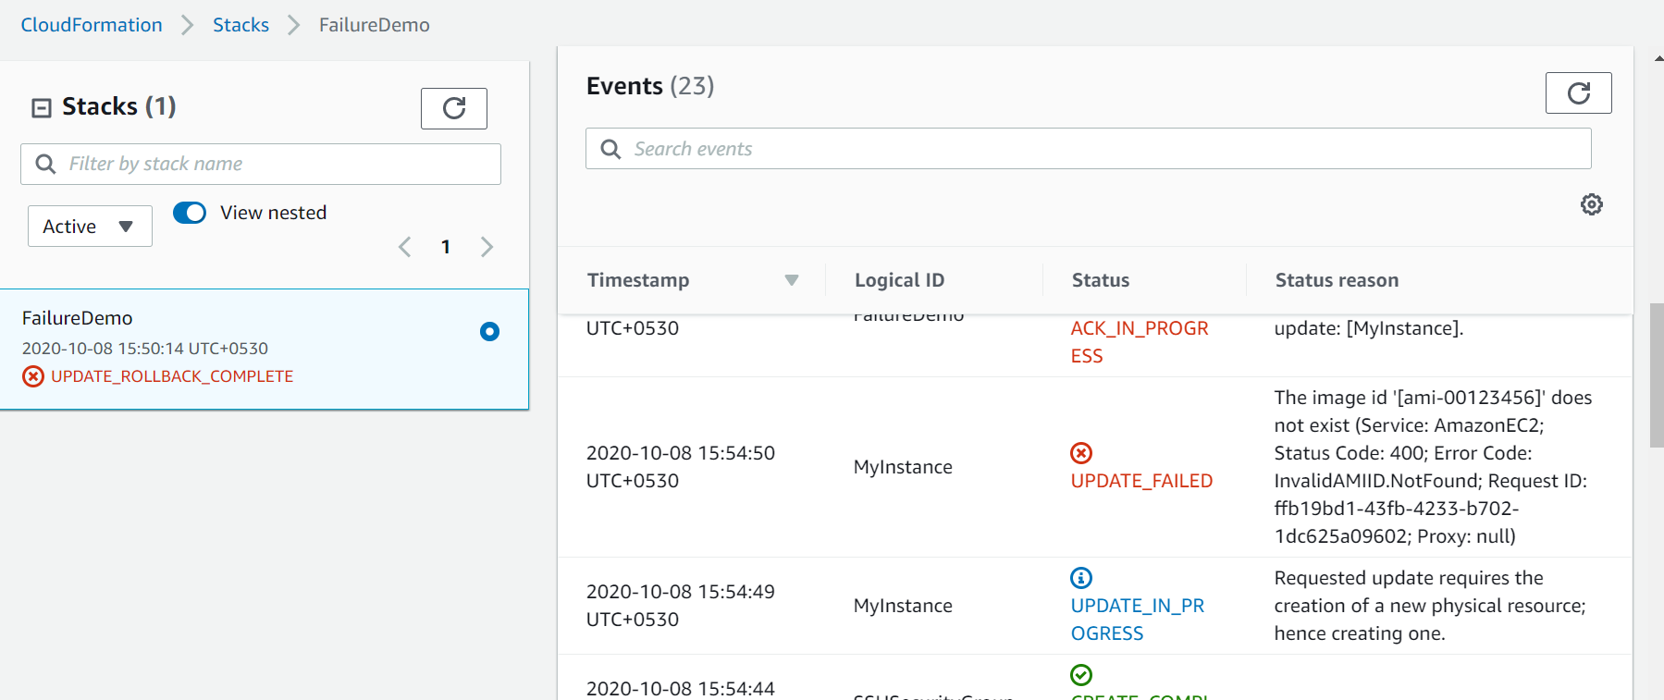

**Therefore update rollback in progress**

**So in this instance if any error came and whatever is update everything will get rollback**

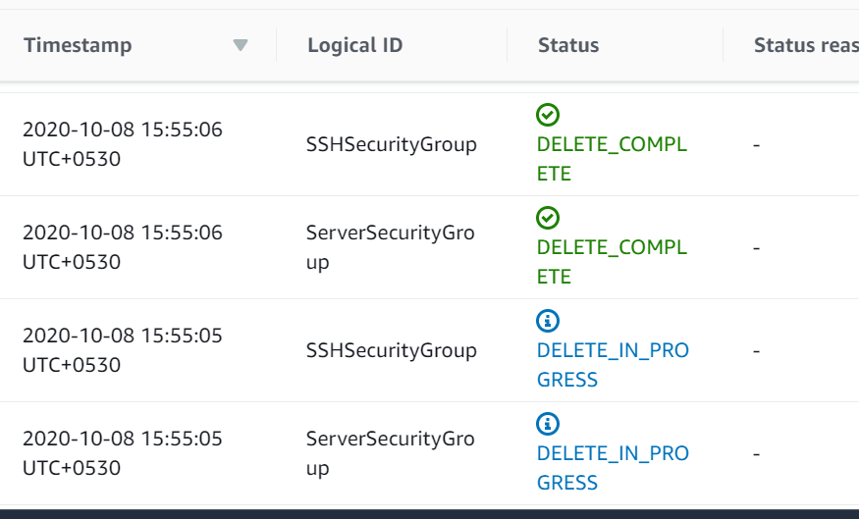

**======================================================================**

**Create stack with new resources**

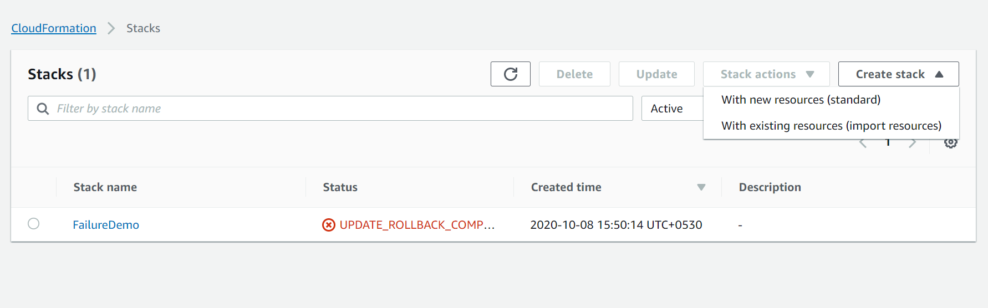

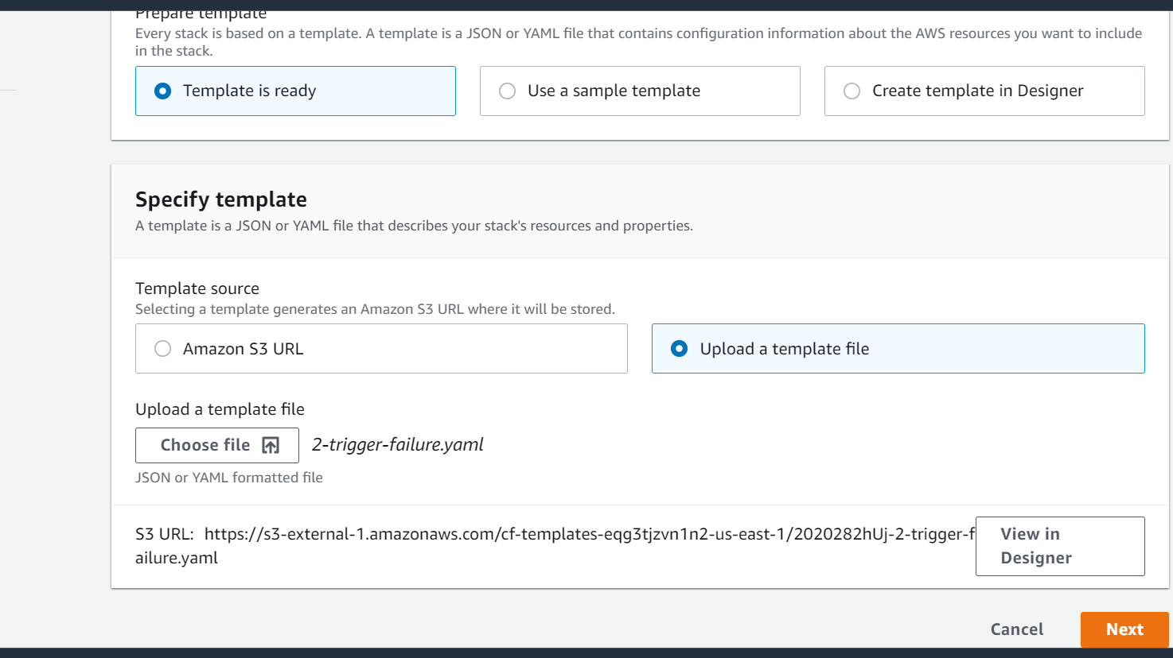

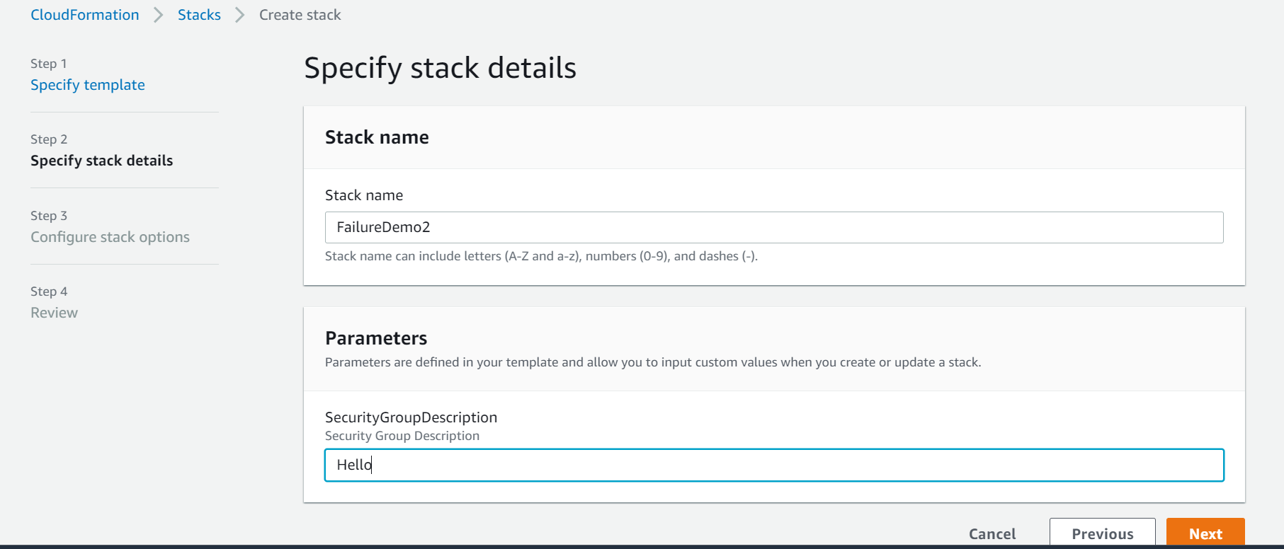

**Note if we want to do trouble shoot we can disabled rollback**

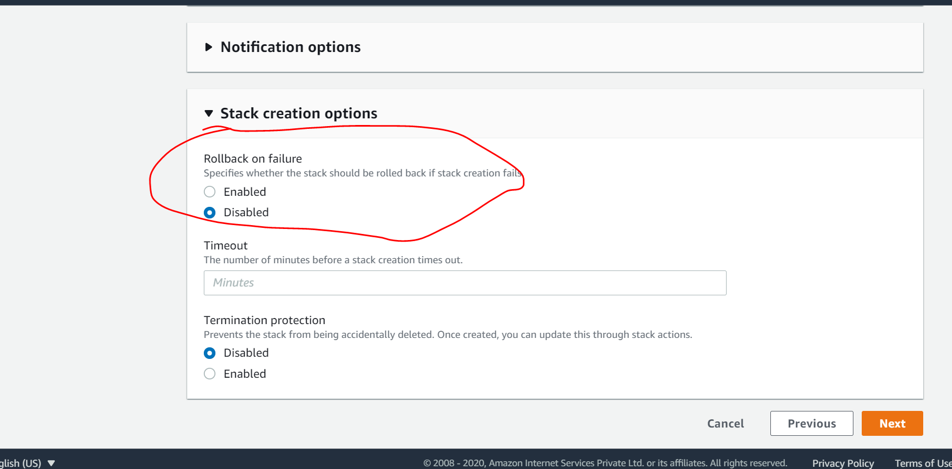

**Cloud formation changesets ,nested stack and stackset**

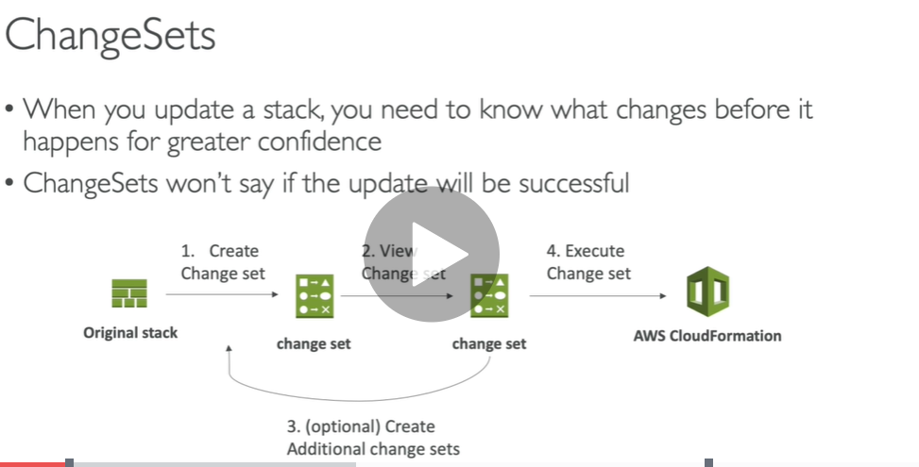

**Security group is resused**

